Index of Facebook Recipe Collection # 1 by Page Number

- Overnight Oatmeal
- Overnight Oatmeal Continued
- Old Fashioned Rice Pudding
- Ice Coffee
- Lemon Lush
- Blt Roll-Ups
- The Best Jell-O Cookies Ever!!!
- Garden Salsa Recipe
- One Cookie
- Banana Bread With Honey And Applesauce
- Lunchroom Ladies 50 Year Old Recipe
- Baked Sweet And Sour Chicken
- Homemade Butterfinger Candy Bars
- Chili's Copycat Salsa Recipe
- Oven Tacos
- Rolo Stuffed Snickerdoodles
- Miss Jean’s Peach Cobbler
- Skor Squares
- Chicken Enchiladas & Enchilada Sauce
- Banana Bread Bars
- Pecan Bars… The Easy Way
- Chilled Stacked Salad
- Cookie Dough Brownie Bars
- Egg Muffins
- Omgosh Peach Cake
- Banana Pudding From Scratch
- Blt Dip
- Peanut Butter Chocolate Chip Cookie Dough Bites
- Divinity
- Caprese Garlic Bread
- Vanilla Ice Cream Recipe
- Chocolate No-Bake Oatmeal Cookies
- Fruit Salad - Ambrosia Style
- Blueberry Squares
- Poor Mans Cobbler!
- Fried Apple Or Peach Pies
- Crock-Pot Chicken Teriyaki
- Almost "Bourbon" Chicken
- Cream Cheese Bars
- Bread And Butter Pickles
- 7 Up Biscuits
- Cracker Barrel Chicken N' Dumplins
- Chocolate Chip Reeses Brownies
- 3 Envelope Roast
- Grandma's Cucumber Salad
- Chicken Apple Wraps
- Crusty Bread (Simply So Good)
- Hamburger Stew
- Lasagna Rolls
- Chicken Crescent Rolls
- Crescent Roll Taco Bake
- Texas Roadhouse Rolls
- Sweet Baby Ray's Crockpot Chicken
- Rice Krispies Rollups
- 2 Ingredient Pumpkin Muffins
- Chicken And Dumpling Casserole
- Cool Whip Cookies
- Banana Bread
- Crock Pot Cinnamon Almonds
- Chocolate Chip Cookie Cheesecake
- Best Ever Sloppy Joes
- Chicken Taco Salad
- Taco Soup
- Slow Cooker Salsa Chicken
- Oven Baked Salsa Chicken
- Taco Chicken Served With Corn Salsa
- Skinny Chunky Monkey Cookies
- Chocolate Mud Cake
- Southwestern Cornbread Layered Salad
- Taco, Ranch, And Onion Mixes
- Crack Rolls
- Philly Steak Sandwich
- Maple Bacon Monkey Bread
- Double Chocolate Coca Cola Cake
- Italian Cream Sodas
- Oven-Baked Zucchini Fries
- No Bake Blueberry Cheesecake
- Homemade Twinkies
- Bacon Wrapped Smokies With Brown Sugar And Butter
- Crockpot Ranch Pork Chops:
- Crock Pot Apple Butter
- Bacon Onion Foil Packs
- Sticky Bun Breakfast Ring
- Crockpot Potato Soup For Weight Watchers
- Peanut Butter Cups
- Jill’s Pork Tenderloin
- Orange Creamsicle Cheesecake
- German Skillet Dinner
- Cream Cheese Mints Recipe
- No-Bake Peanut Butter Bars
- Mexican Pizza Recipe
- Best Ever Light And Fluffy Dinner Rolls
- Six Minute Caramels
- Broccoli Quiche (Low Carb)
- Mock Filet Mignon
- Fried Rice
- Bacon Cheddar Pull-Apart Bread
- Roasted Sweet Potatoes
- Bacon And Potato Bake
- Chicken & Cheese Enchiladas With Green Chili & Sour Cream Sauce
- Pineapple Pecan Cake With Cream Cheese Frosting
- Hershey Kisses Witches Hats
- Sausage, Egg And Biscuits Casserole
- Cheeseburger Paradise Pie
- Raspberry Whip
- Caprese Lasagna Roll Ups
- Cotton Candy Salad
- Impossible Pie
- Pepperoni & Mozzarella Stuffed Chicken Breasts

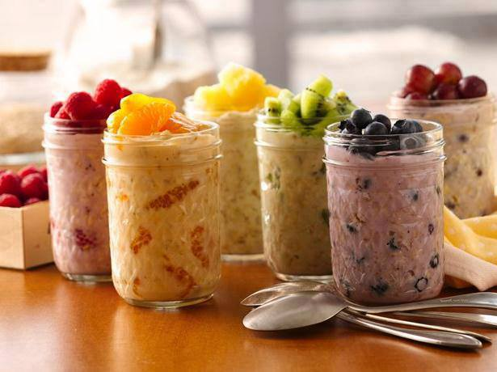
Overnight Oatmeal
Make them the night before and have a quick healthy breakfast ready to grab and go!!
INGREDIENTS
1 container (6 oz) greek yogurt, any flavor
1/4 cup uncooked old-fashioned or quick-cooking oats
1/4 cup fruit (see ideas below)
Instructions:
In container with tight-fitting cover, mix yogurt and uncooked oats. Stir in desired fruit.
Cover; refrigerate at least 8 hours but no longer than 3 days before eating.
Passionate Overnight Oatmeal: Stir in 1/4 cup raspberries.
Energized Overnight Oatmeal: Stir in 1/4 cup mandarin orange segments.
Positive Overnight Oatmeal: Stir in 1/4 cup pineapple pieces.
Harmonious Overnight Oatmeal: Stir in 1/4 cup diced kiwifruit.
Relaxed Overnight Oatmeal: Stir in 1/4 cup blueberries.
Romantic Overnight Oatmeal: Stir in 1/4 cup sliced grapes.
Stir-ins German Chocolate Cake Overnight Oatmeal: Stir in 1 tablespoon chocolate chips and 1 tablespoon unsweetened coconut. Calories 250 (Calories from Fat 70); Total Fat 8g (Saturated Fat 5g, Trans Fat 0g); Cholesterol 0mg; Sodium 0mg; Potassium 140mg; Total Carbohydrate 38g (Dietary Fiber 3g); Protein 8g
S'mores Overnight Oatmeal: Stir in 1 tablespoon chocolate chips and 2 tablespoons miniature marshmallows. Calories 240 (Calories from Fat 40); Total Fat 4.5g (Saturated Fat 2g, Trans Fat 0g); Cholesterol 0mg; Sodium 5mg; Potassium 110mg; Total Carbohydrate 42g (Dietary Fiber 2g); Protein 8g
Bananas Foster Overnight Oatmeal: Stir in 1/2 sliced banana and 1 tablespoon chocolate chips. Calories 280 (Calories from Fat 40); Total Fat 4.5g (Saturated Fat 2g, Trans Fat 0g); Cholesterol 0mg; Sodium 0mg; Potassium 320mg; Total Carbohydrate 50g (Dietary Fiber 4g); Protein 8g
Peanut Butter Cup Overnight Oatmeal: Stir in 1 tablespoon each chocolate chips and peanut butter chips. Calories 270 (Calories from Fat 70); Total Fat 8g (Saturated Fat 3g, Trans Fat 0g); Cholesterol 0mg; Sodium 30mg; Potassium 150mg; Total Carbohydrate 42g (Dietary Fiber 3g); Protein 9g
Overnight Oatmeal – Page 2

Stir-ins Pomegranate Power Oatmeal: Stir in 1/4 cup pomegranate seeds. Calories 230 (Calories from Fat 25); Total Fat 2.5g (Saturated Fat 0g, Trans Fat 0g); Cholesterol 0mg; Sodium 60mg; Potassium 180mg; Total Carbohydrate 34g (Dietary Fiber 4g); Protein 16g
Honey Power Oatmeal: Stir in 1 tablespoon honey or 2 tablespoons comb honey.* Calories 260 (Calories from Fat 20); Total Fat 2g (Saturated Fat 0g, Trans Fat 0g); Cholesterol 0mg; Sodium 60mg; Potassium 90mg; Total Carbohydrate 43g (Dietary Fiber 3g); Protein 16g
Banana Power Oatmeal: Stir in 1/4 cup banana slices. Calories 220 (Calories from Fat 20); Total Fat 2g (Saturated Fat 0g, Trans Fat 0g); Cholesterol 0mg; Sodium 55mg; Potassium 210mg; Total Carbohydrate 34g (Dietary Fiber 4g); Protein 16g
Almond Power Oatmeal: Stir in 1/4 cup toasted almonds. Calories 330 (Calories from Fat 120); Total Fat 13g (Saturated Fat 1g, Trans Fat 0g); Cholesterol 0mg; Sodium 55mg; Potassium 240mg; Total Carbohydrate 31g (Dietary Fiber 6g); Protein 21g
Blueberry Power Oatmeal: Stir in 1/4 cup blueberries. Calories 210 (Calories from Fat 20); Total Fat 2g (Saturated Fat 0g, Trans Fat 0g); Cholesterol 0mg; Sodium 55mg; Potassium 105mg; Total Carbohydrate 31g (Dietary Fiber 4g); Protein 16g
Blackberry Power Oatmeal: Stir in 1/4 cup blackberries. Calories 200 (Calories from Fat 20); Total Fat 2.5g (Saturated Fat 0g, Trans Fat 0g); Cholesterol 0mg; Sodium 55mg; Potassium 135mg; Total Carbohydrate 29g (Dietary Fiber 5g); Protein 16g
*Those with bee sting allergies should consult their physician before consuming comb honey.
To toast almonds, sprinkle in ungreased heavy skillet. Cook over medium heat 5 to 7 minutes, stirring frequently until almonds begin to brown, then stirring constantly until almonds are light brown.
Via: Betty Crocker

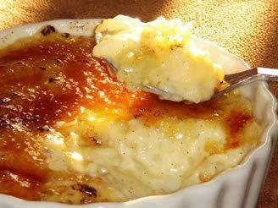
OLD FASHIONED RICE PUDDING
2/3 c. Minute Rice
2 3/4 c. milk
1/3 c. sugar
1 tbsp. butter
1/2 tsp. salt
1/2 tsp. vanilla
1/4 tsp. nutmeg
Cinnamon
1/2 c. raisins
Combine Minute Rice, milk and raisins, sugar, butter, salt, vanilla and nutmeg in a buttered 1 quart baking dish. Bake in 350 degree oven for 1 hour, stirring after 15 minutes and again when pudding is done. Sprinkle with cinnamon. Serve warm or chilled. Pudding thickens as it stands.

ICE COFFEE

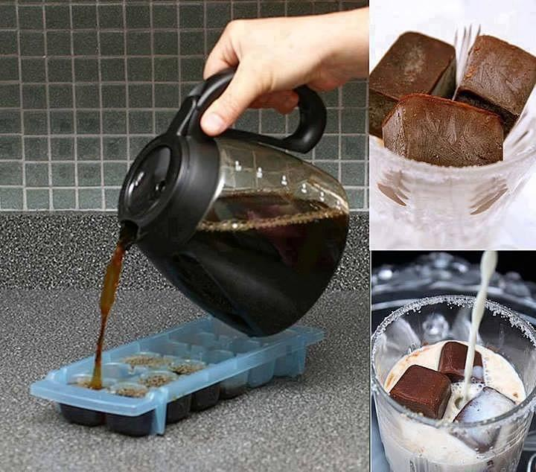

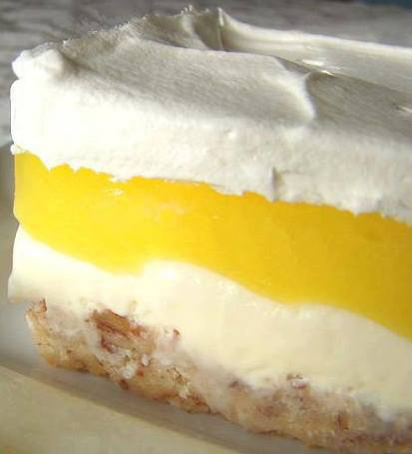
Lemon Lush
1 cup flour
1/2 cup butter
1/2 cup chopped pecans
8 ounces cream cheese
1 cup powdered sugar
1 (8 ounce) container whipped topping, divided
1 (3 ounce) box lemon pudding mix
1/2 cup sugar
2 1/4 cups water, divided
2 egg yolks
Mix flour, butter& chopped pecans together like biscuit dough and press into 8 x 8 inch baking pan. Bake at 400° for 20 minutes or until brown.
Mix together cream cheese, powdered sugar and 1 cup whipped topping and spread over first layer while still warm. Stir lemon pudding mix, sugar, 1/4 cup water and egg yolks together in a medium saucepan. Stir in 2 cups water. Stirring constantly, with wire whisk, cook on medium heat until mixture comes to a full boil. (NOTE: if you are using instant pudding or a different flavor, use the ingredients & directions for preparation on the package!).
Cool 5 minutes, stirring twice. Cool about 30 minutes more and spread over two previous layers. Cool completely and top with remaining whipped topping. Chill.

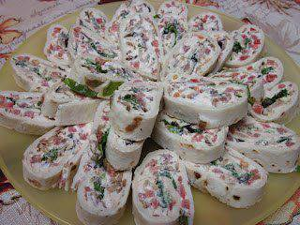
BLT Roll-Ups
8 oz. cream cheese
1/2 cup mayo
8-10 slices center cut bacon, cooked and crumbled
1 cup chopped tomatoes
4 eight-inch flour tortillas
1 cup shredded romaine lettuce
Mix cream cheese and mayo in a bowl. Add crumbled bacon and diced tomatoes. Spread mixture on tortillas and top with lettuce. Roll up tightly and refrigerate for an hour. Slice into 1/2 inch slices.

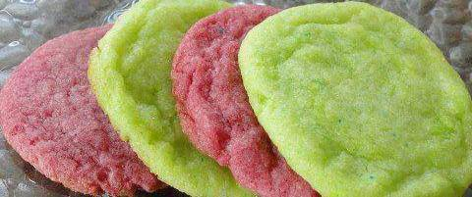
The BEST Jell-O cookies EVER!!!
1 and 3/4 cups flour
1/2 tsp. baking powder
3/4 cups softened butter
1/2 cup granulated sugar
1 egg white
½ tsp. vanilla
2- three oz. packages of Jell-O (you can double the recipe and have 4 packs of Jell-O)
Beat the butter and sugar together. Add the egg white and vanilla. In a separate bowl mix the flour and baking powder then combine with butter mixture. Divide the dough in half and knead one small box of Jell-O into each half. Shape into balls and flatten onto an ungreased cookie sheet 2 inches apart with a spoon or fork. Bake at 350 for 10 minutes. Let cool for a couple minutes before removing from cookie sheet.

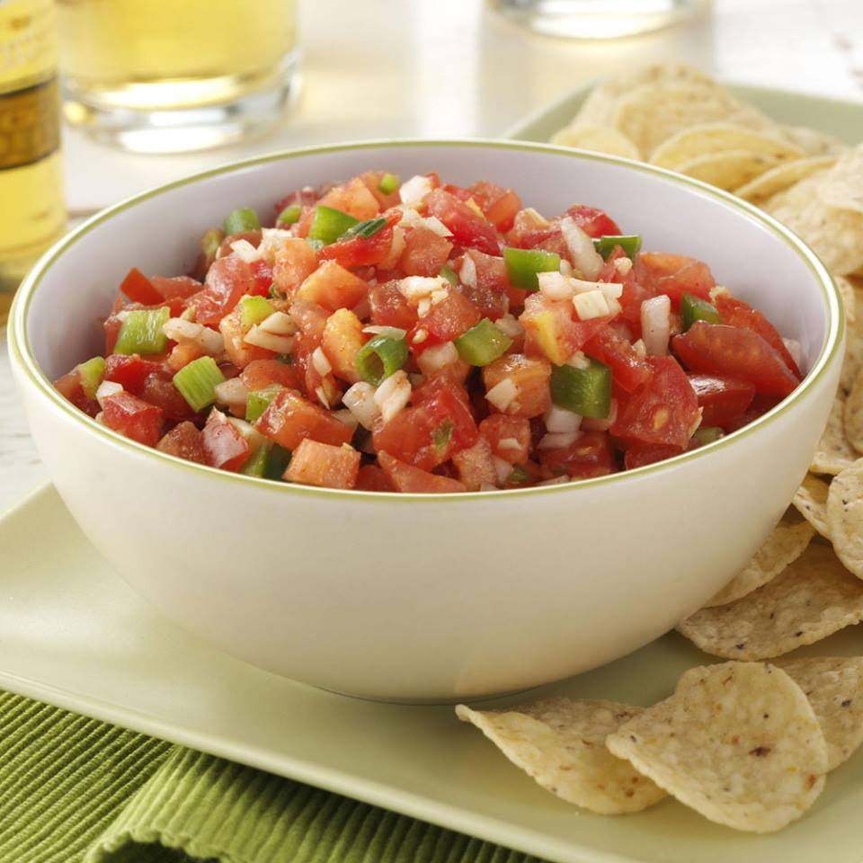
Garden Salsa Recipe
- 6 medium tomatoes, finely chopped
- 3/4 cup finely chopped green pepper
- 1/2 cup finely chopped onion
- 1/2 cup thinly sliced green onions
- 6 garlic cloves, minced
- 2 teaspoons cider vinegar
- 2 teaspoons lemon juice
- 2 teaspoons olive oil
- 1 to 2 teaspoons minced jalapeno pepper
- 1 to 2 teaspoons ground cumin
- 1/2 teaspoon salt
- 1/4 to 1/2 teaspoon cayenne pepper
- Tortilla chips

Directions
- In a large bowl, combine the tomatoes, green pepper, onions, garlic, vinegar, lemon juice, oil, jalapeno and seasonings. Cover and refrigerate until serving. Serve with chips. Yield: 5 cups.
Editor's Note: Wear disposable gloves when cutting hot peppers; the oils can burn skin. Avoid touching your face.
Nutritional Facts2 tablespoons of salsa equals 17 calories, trace fat (0 saturated fat), 0 cholesterol, 62 mg sodium, 3 g carbohydrate, trace fiber, trace protein. Diabetic Exchanges: Free Food.

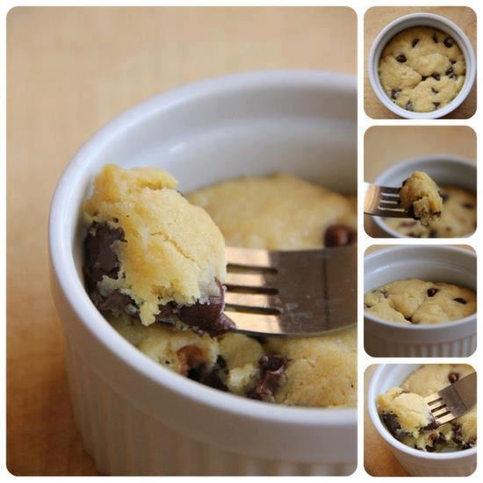
ONE COOKIE

OR THOSE DAYS WHEN YOU JUST WANT TO MAKE ONE COOKIE! 1 tbsp butter melted... 1 tbsp white sugar... 1 tbsp brown sugar... 3 drops of vanilla... pinch of salt... 1 egg yolk... 1/4 cup flour... 2 tbsp chocolate chips... MICROWAVE 40-60 SEC IN A CUP OR BOWL... Single serving deep dish chocolate chip cookie!

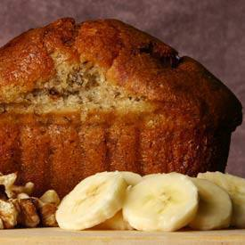

Banana Bread with honey and applesauce
instead of sugar & oil. Delicious & Healthy.
Ingredients
2 cups whole wheat flour
1 teaspoon baking soda
1/4 teaspoon salt
1/2 cup sugar free applesauce
3/4 cup honey
2 eggs, beaten
3 mashed overripe bananas
Directions
Preheat oven to 350 degrees F (175 degrees C). Lightly grease a 9x5 inch loaf pan.
In a large bowl, combine flour, baking soda and salt. In a separate bowl, mix together applesauce and honey. Stir in eggs and mashed bananas until well blended. Stir banana mixture into flour mixture; stir just to moisten. Pour batter into prepared loaf pan.
Bake in preheated oven for 60 to 65 minutes, until a toothpick inserted into center of the loaf comes out clean. Let bread cool in pan for 10 minutes, then turn out onto a wire rack.

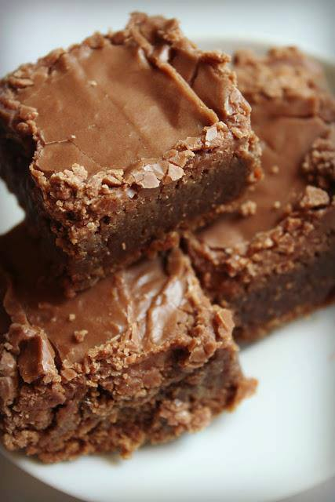
Lunchroom Ladies 50 year old recipe.

1 c butter ,
1/2 c cocoa,
2 c flour,
2 c sugar,
4 eggs,
4 tsp vanilla,
1 c chopped nuts.

Pour in 9x13 pan, bake 20-25 mins on 350.Check at 20 mins**

Icing*
1/4 c softened butter
¼ c can milk (regular milk is fine)
1/4 c cocoa,
3 c powdered sugar,
dash salt,

Mix all together & frost as desired.

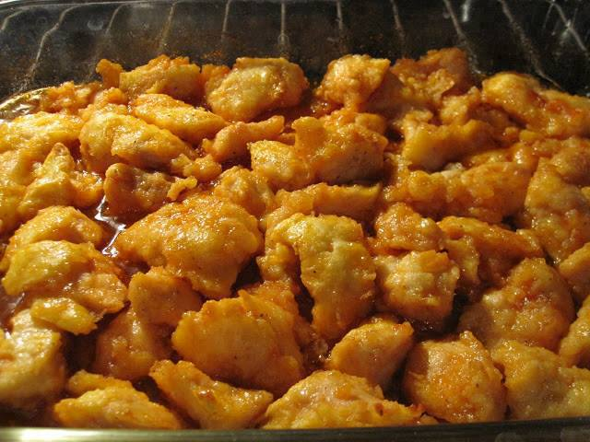

Baked Sweet and Sour Chicken
THE CHICKEN COATING:
3-4 boneless chicken breasts
salt + pepper
1 cup cornstarch
2 eggs, beaten
1/4 cup canola oil
THE SWEET AND SOUR SAUCE:
3/4 cup sugar
4 tbs ketchup
1/2 cup distilled white vinegar
1 tbs soy sauce
1 tsp garlic salt
1 can Pineapple chunks
Start by preheating your oven to 325 degrees. Rinse your chicken breasts in water and then cut into cubes. Season with salt and pepper to taste. Dip chicken into the cornstarch to coat then dip into the eggs. Heat your 1/4 cup oil in a large skillet and cook your chicken until browned but not cooked through. Place the chicken in a 9x13 greased baking dish. Mix all of your sweet and sour sauce ingredients in a bowl with a whisk and then pour evenly over the chicken. Bake for one hour and during the baking process you will need to turn the chicken every 15 minutes.

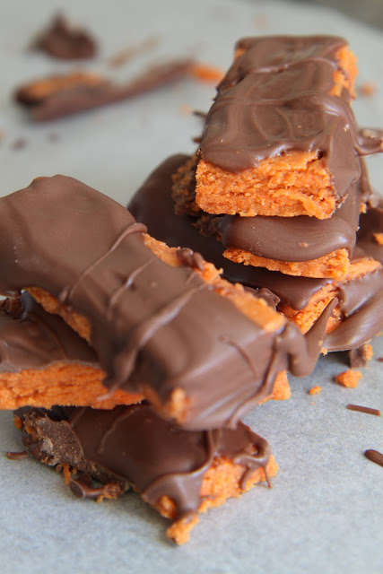

HOMEMADE BUTTERFINGER CANDY BARS

1 lb. candy corn
16oz jar peanut butter (I used Peter Pan Honey Roasted peanut butter)
16oz pkg. chocolate candy coating
Melt candy corn in microwave on high 1 minute. Stir and continue cooking in 15-second intervals til melted, stirring after each interval. Stir in peanut butter. Spread mixture in an 8x8 pan lined with parchment. Cool completely. Cut into squares. Dip in melted chocolate candy coating. Lay on waxed paper to set.

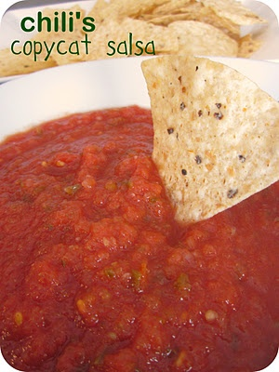

Chili's Copycat Salsa Recipe:
Ingredients:
2 cans (14.5 oz each) whole tomatoes, drained
3-4 canned, whole jalapenos (not pickled)
1 yellow onion, quartered
1 teaspoon garlic salt
1/2 teaspoon salt
1 teaspoon cumin
1/2 teaspoon sugar
2 teaspoons lime juice

Directions:
Place all of the ingredients together into a food processor or blender and puree until smooth. Serve with tortilla chips.

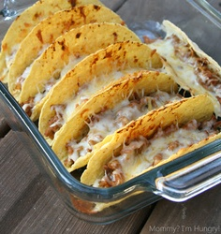

Oven Tacos
2 lbs ground beef (or turkey/chicken)
1 small onion diced
1 small can diced green chilies
1 recipe for Homemade taco seasoning (below)
1 (8 ounce) can low sodium tomato sauce
1 (16 ounce) can fat free refried beans
2 cups shredded reduced fat Colby-jack cheese
18-20 hard taco shells {if gluten free, be sure they are}
Optional Condiments-
Lettuce (shredded), Tomato (diced) , Salsa , Guacamole , Sour Cream, Olives, sliced
Preheat the oven to 400 degrees.
In a large skillet brown ground beef and onion over medium-high heat. Drain off any excess liquid. Return to pan, add chilies, refried beans, tomato sauce, and taco seasoning. Mix well and cook for a few minutes if mixture seems runny.
Spoon the taco meat mixture into the taco shells and place into a 9 x 13 inch baking dish (OR check out The Taco Rack), standing up. Sprinkle cheese over the top of the taco meat in each shell. Place into the oven and bake at 400 degrees for 10-12 minutes or until the cheese has melted and the tacos are heated through.
Remove from the oven and top with any optional condiments for serving.
Taco Seasoning
1 tablespoon chili powder
1/4 teaspoon garlic powder
1/4 teaspoon onion powder
1/4 teaspoon crushed red pepper flakes
1/4 teaspoon dried oregano
1/2 teaspoon paprika
1 1/2 teaspoons ground cumin
1 teaspoon sea salt
1 teaspoon black pepper
In a small bowl, mix all together. Store in an airtight container. I used all of this on 2 lbs of ground meat with a little water mixed in.
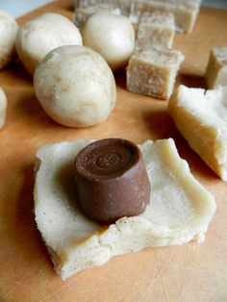

Rolo Stuffed Snickerdoodles

Ingredients
- 1 batch store-bought or homemade snickerdoodles
- 32 rolo candies
Instructions
- Preheat oven to 325 degrees. Flatten 1 tablespoon dough and wrap around Rolo candy. Roll into ball and set on cookie sheet.
- Bake for 14 minutes. Allow to cool thoroughly before attempting to remove from baking sheet.This is the littlest effort ever required for a seemingly gourmet cookie.

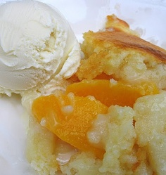
Miss Jean’s Peach Cobbler
4 cups fresh peaches sliced* or 29 ounce can sliced peaches in heavy syrup
1 1/2 cups self-rising flour**
1 1/2 cups milk
1 cup sugar
1 stick butter, melted
In a 9×13 inch dish pour melted butter. Mix flour, milk, and sugar to make a smooth batter. Pour batter over melted butter. Put fruit on top, syrup and all. Bake in a 350 degree oven for 40-45 minutes. Let set 10 minutes before serving. Serves about 10.
* if using fresh fruit, add extra sugar to the fruit, about 1/2 cup
** if using plain flour, add: 2 tsp. baking powder and 1/4 tsp. salt to the flour.

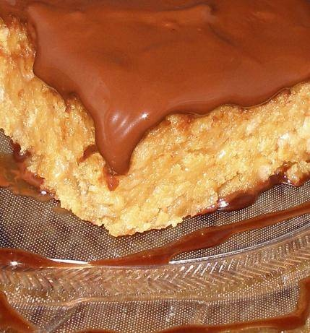

Ingredients for Skor Squares:
- 1 (250 g) box Ritz crackers
- 1 (200 g) package Skor English toffee bits
- 1 (300 ml) can condensed milk
- 1 cup chocolate chips

Preparation of Skor Squares:
- Preheat oven to 350°F.
- Line the bottom on an 8 inch square baking pan with parchment paper, allowing 2 inches to hang over each end.
- In a blender or food processor, process crackers until fine.
- Place in a bowl and stir in Skor Bits and condensed milk.
- Spoon into prepared pan.
- Smooth top surface.
- Sprinkle chocolate chips on top.
- Bake 20 minutes or until edges become brown.
- Immediately smear chocolate with a spatula to smooth the chocolate.
- Cool on a rack for a couple hours before removing from pan and cutting.

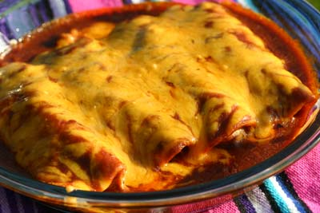
CHICKEN ENCHILADAS

1 whole chicken (makes 15 - 18 enchiladas) or
5-6 thighs (9 - 12 enchiladas)
Corn tortillas
vegetable oil
12 oz. of mild cheddar cheese, grated
1/2 cup yellow onion, finely chopped
enchilada sauce
sour cream optional
guacamole optional

Directions:
Personally, I think dark meat makes the chicken enchilada recipes better than white meat. The choice is yours. Rinse your chickens in cold water and place them in a pot and fill with water. You are going to boil the chicken for 1/2 hour. Always test your chicken to make sure it is done. You don't want to see any red juices coming out of the chicken. When done, remove the chicken to a dish to cool off. When the chicken is cool enough to touch, you will debone the chicken. Discard the skin, bones, grisle, and any other parts you don't want to eat! Try not to leave your chicken out at room temperature too long. You don't want to encourage bacterial growth. Place your deboned chicken on a clean cutting board and cut the chicken into approximately 1 inch chunks.If you have ever considered buying one good knife for your kitchen, here is one I have been happy with. I use it all the time and love it. It's razor sharp and lightweight. At this point you can start assembling your chicken enchiladas. If you want to keep your chicken warm just put it in a pot on the stove in the juice it was cooked in. Heat the vegetable oil on medium high heat in a pan big enough to fit the tortillas in. When the oil is hot, take two tortillas with tongs and hold them in the oil until they bubble. The tortillas should bubble right away. If they don't, your oil is not hot enough. Lift and dip the tortillas in and out of the oil 3 times fairly quickly.

Enchilada Sauce

- 2 cups low sodium chicken broth
- 4 tsp. Gebhardt Chile Powder, or use 4Tbsp if you like it hot!
- 1 tsp. ground cumin
- 2 tsp. garlic powder
- 3/4 tsp. salt
- 1 pinch ground cinnamon (less than 1/16 tsp.)
- a little less than 1/2 tsp. sugar
- 3 Tablespoons plus 1/4 tsp. white flour
- 3 Tablespoons vegetable oil

Directions:
First let's make a roux. In a 2 quart sauce pan add the oil over medium high heat. When the oil is hot, lower the heat to low and add the flour. Mix with a wire whisk for about 1 to 2 minutes stirring constantly. You want to see a little bubble going on. Then add the chile powder and whisk in till fully mixed. Slowly pour in the 2 cups chicken broth. Turn the heat up to medium again and stir till fully mixed. Add the cumin, garlic powder, salt, cinnamon and sugar (the sugar is a little secret to eliminate any bitter taste from the chile powder) stirring after each addition. Bring to a boil as you continue to stir. Once boiling, stir and cook for 3 to 5 minutes. Turn off the heat, this enchilada sauce recipe is done. You will notice that as this sauce sits it will form a "skin" on the surface. This is normal and in fact the longer the sauce sits the thicker this skin becomes. All you have to do is peel the skin off and throw it away. As you can see, this enchilada sauce recipe is very quick to make.
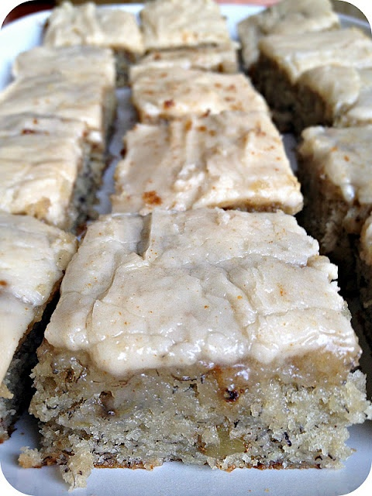
Banana Bread Bars:

Ingredients:
1-1/2 c. sugar
1 c. sour cream
1/2 c. butter, softened
2 eggs
1-3/4 (3 or 4) ripe bananas, mashed
2 tsp. vanilla extract
2 c. all purpose flour
1 tsp. baking soda
3/4 tsp. salt
1/2 c. chopped walnuts (optional)

Brown Butter Frosting:
1/2 c. butter
4 c. powdered sugar
1-1/2 tsp. vanilla extract
3 tbsp. milk

﻿Directions:
1. Heat oven to 375F. Grease and flour 15x10-inch jelly roll pan. For the bars, in a large bowl, beat together sugar, sour cream, butter, and eggs until creamy. Blend in bananas and vanilla extract. Add flour, baking soda, salt, and blend for 1 minute. Stir in walnuts.
2. Spread batter evenly into pan. Bake 20 to 25 minutes or until golden brown.
3. Meanwhile, for frosting, heat butter in a large saucepan over medium heat until boiling. Let the butter turn a delicate brown and remove from heat immediately.
4. Add powdered sugar, vanilla extract and milk. Whisk together until smooth (it should be thicker than a glaze but thinner than frosting). Using a spatula, spread the brown butter frosting over the warm bars (the frosting will be easier to spread while the bars are still warm).

Yield: 2 dozen large bars﻿

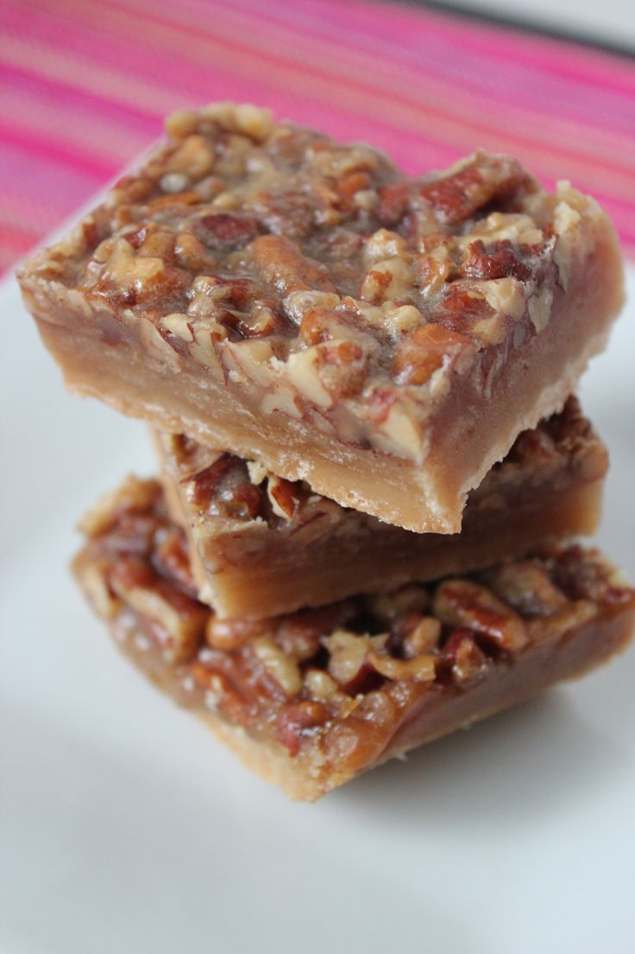
PECAN BARS… THE EASY WAY

INGREDIENTS
FOR CRUST:
2 sticks unsalted butter, softened
2/3 cup packed brown sugar
2 2/3 cups all-purpose flour
½ teaspoon salt
FOR TOPPING:
1 stick (½ cup) unsalted butter
1 cup packed light brown sugar
1/3 cup honey
2 tablespoons heavy cream
2 cups chopped pecans

1) Preheat the oven to 350ºF and line a 9×13-inch pan with foil, leaving enough for a 2-inch overhang on all sides. (I sprayed my foil with non-stick cooking spray, just in case)
2) First make the crust by creaming together the butter and brown sugar until fluffy in a stand mixer fitted with the paddle attachment. Add in the flour and salt and mix until crumbly.
3) Press the crust into the foil-lined pan and bake for 20 minutes until golden brown.
4) While the crust bakes, prepare the filling by combining the butter, brown sugar, honey and heavy cream in a saucepan and stirring it over medium heat. Simmer the mixture for 1 minute, then stir in the chopped pecans.
5) Remove the crust from the oven and immediately pour the pecan filling over the hot crust spreading it to cover the entire surface.
6) Return the pan to the oven and bake an additional 20 minutes.
7) Remove the pan and allow the bars to fully cool in the pan.
8) Use the foil overhang to lift out the bars and transfer them to a cutting board. Peel off the foil, slice into bars.
9) *An optional, highly recommended last step, stolen from Ina – DIP THE ENDS IN CHOCOLATE! Milk or Dark – you won’t be sorry! I didn’t do it this time, but, it will only make them that much more amazing.
Well what’s the verdict? Could these put Ina out of business? I think so! They were absolutely delicious. Not quite as thick and hearty as hers, but that means you get to eat more of them! The same great flavor, without all the hassle, time, and BUTTER.

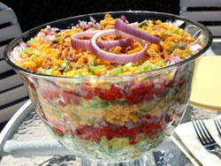
Chilled Stacked Salad
is a colorful and easy make-ahead layered salad that is perfect for easy summer entertaining. It's among our favorite easy salad recipes for potluck parties. We know once you start stacking, you'll never want to stop!
What You'll Need:

2 cups mayonnaise
1/2 cup sour cream
1/2 teaspoon garlic powder
1 head romaine or iceberg lettuce,
chopped 2 red bell peppers, finely chopped
1 red onion, finely chopped
1 (9-ounce) package frozen corn, thawed and drained
3 ribs celery, finely chopped 2 cups
(8 ounces) shredded sharp Cheddar cheese
1 (3-ounce) container real bacon bits

What To Do:
In a medium bowl, combine mayonnaise, sour cream, and garlic powder; mix well. In a large glass bowl (see Note), layer half the lettuce then half the bell pepper, onion, corn, celery, mayonnaise mixture, and cheese. Repeat layers once more then top with bacon bits. Cover and chill at least 2 hours before serving. Toss just before serving.
Note Using a trifle dish or large glass bowl with straight sides allows us to see all the colorful layers of this salad.
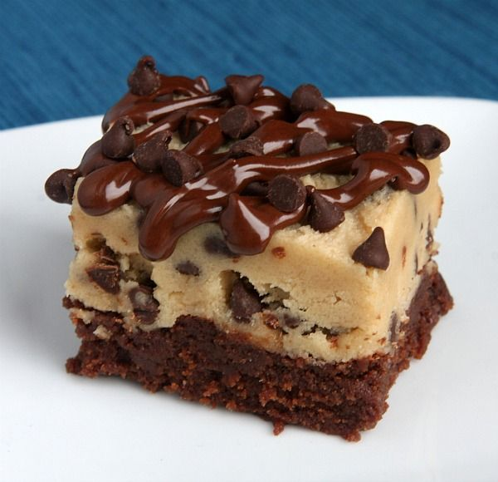
COOKIE DOUGH BROWNIE BARS

BROWNIE:
4 ounces unsweetened chocolate, finely chopped
1 cup salted butter, melted
2 cups light brown sugar, packed
4 large eggs
2 teaspoons vanilla extract
1 cup all-purpose flour
1/2 cup mini- chocolate chips

COOKIE DOUGH (EGG FREE!): **See Tips Below...**
3/4 cup salted butter, at room temperature
3/4 cup light brown sugar, packed
3/4 cup granulated white sugar
3 Tablespoons milk
1 1/2 teaspoons vanilla extract
1 1/2 cups all-purpose flour
1 1/2 cups mini chocolate chips
1/2 cup semisweet chips + 1 teaspoon shortening for drizzle, optional

Directions: Prepare the brownies: Preheat oven to 325 degrees F. Spray a 9x13-inch pan with nonstick spray. In a medium glass bowl, melt chocolate in the microwave in short bursts of 30 seconds; stir after each burst and remove from microwave when melted and smooth. Set aside to cool slightly. In a large mixing bowl, whisk together the butter and brown sugar. Add the eggs and vanilla extract and whisk those in too. Mix in melted chocolate. Whisk in the flour and mix just until combined (don't over-mix). Stir in the chocolate chips. Spread batter into prepared pan. Bake 25 to 35 minutes. Watch closely and remove from oven when toothpick inserted into the center comes out clean. Let cool completely. Prepare the cookie dough: In a medium bowl, use an electric mixer to combine butter, brown sugar and white sugar. Mix in milk and vanilla. Mix in flour just until combined. Stir in chocolate chips. Spread cookie dough over the cooled brownies. Refrigerate until the dough is quite firm. It's okay to speed up the process and place it in the freezer too. The firmer the dough, the easier it will be to cut into neat squares. Use a sharp knife to cut the brownies. You may need to wipe the knife off with a paper towel in between cuts since the fudgy brownies and cookie dough will tend to stick to the knife a bit. These brownies are best to serve placed inside cupcake papers and served with a fork. If you'd like to add chocolate drizzle on top, melt 1/2 cup chocolate chips with 1 teaspoon of shortening in the microwave; stir until smooth. Scoop the melted chocolate into a zip baggie and snip off the corner. Squeeze the bag to drizzle the chocolate on top of each brownie. Sprinkle additional chocolate chips on top, if desired.

Tips: You'll find that the cookie dough layer is quite sweet. If you'd like a thin layer of cookie dough, prepare the recipe as directed above. If you'd like a thicker layer of dough as pictured, use these ingredients for the dough instead of what is listed above:
1 cup salted butter, at room temperature
1 cup packed light brown sugar
1 cup granulated white sugar
1/4 cup milk
1 1/2 teaspoons vanilla extract
1 3/4 cups + 2 tablespoons all-purpose flour

2 cups miniature chocolate chips

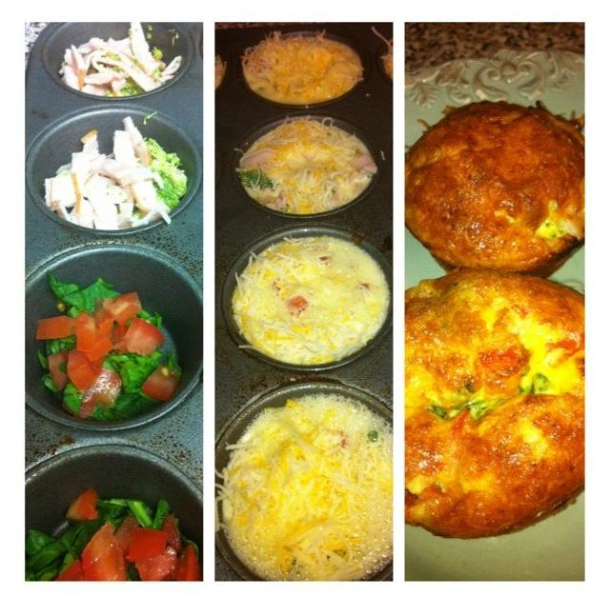
Egg Muffins
These are one of my all-time favorite & EASY meal-preps.
Spray a muffin/cupcake pan w/ non-stick spray.
Fill with ANYthing you want: ham & broccoli, chicken & carrots, spinach w/ feta & tomatoes, steak & bell peppers....whatever you have in the fridge. (Note: add all veggies RAW - they will cook to perfection during the baking process)
Mix approx 1 egg per/muffin in a blender w/ a splash of milk. Pour directly into each cup just below the rim.
Top with shredded or sliced cheeses of your choice.
Bake at 425 degrees for approx 20 min.
Let cool before removing from pan
These can be stored in your fridge for up to 3-4 days! Simply warm in the microwave for a quick breakfast on-the-go!
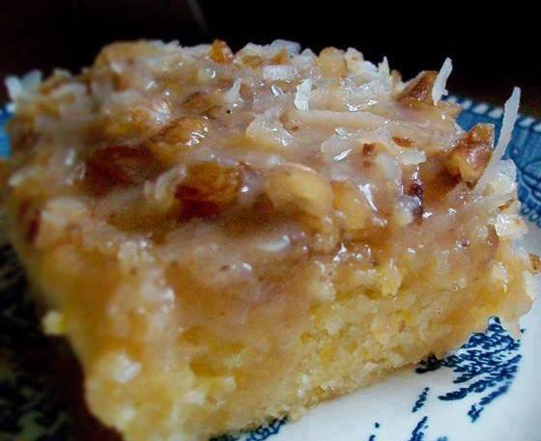
OMGOSH Peach Cake
(NO EGGS)
1 large can sliced peaches, drained and mashed (I used 2 regular cans since that is all I had at the time) You could also use fresh peaches.
2 cups all-purpose flour
2 cups sugar
2 teaspoons baking soda
1 teaspoon salt
Drain the peaches and empty into a large bowl. I just used my hands to mash them. Add flour, sugar and soda and mix well. Spray a 9 x 13 inch cake pan and pour in batter. Bake in a preheated 350F degree oven for 35 minutes. See recipe below for icing.
ICING:
3/4 cup sugar
3/4 regular sized can of evaporated milk
1 stick butter or margarine
1 cup coconut (I used a little more than a cup of coconut)
1 cup nuts
Boil everything but the nuts on top of the stove until thickens, remove from heat, stir in nuts and spread on cooled cake.
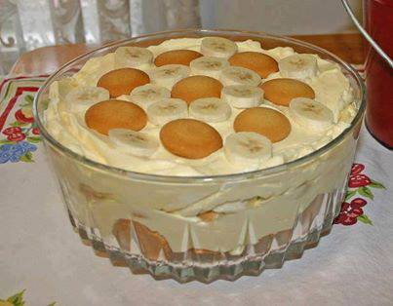
BANANA PUDDING FROM SCRATCH
1/2 c. sugar
2 tbsp. flour
1/4 tsp. salt
2 c. milk
4 separated eggs
1 tbsp. vanilla flavor
1 box of Nilla Vanilla Wafers
4 med. ripe bananas
Mix flour, salt, and sugar; add milk slowly. Stir constantly over low heat until thickened. Stir and cook for about 15 minutes. Beat egg yolks in bowl and stir into mixture slowly stirring constantly. Cook about 5 more minutes stirring constantly. Remove from heat and add vanilla. Line bottom of casserole dish with vanilla wafers, bananas (sliced) and custard mixture. Repeat layers, ending with custard on top. Beat egg whites until stiff. Add 1/4 cup sugar; whip until it peaks. Spread on top of custard and bake in oven at 450 degrees for about 5 minutes or until browned. Remove from oven and serve.

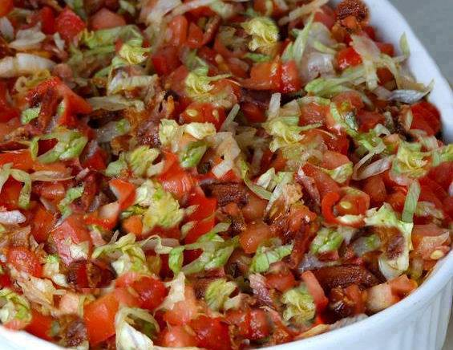
BLT Dip
OMG!!!!! Warning, it went so fast I barely had time to try it!!!!
To SAVE this recipe, be sure to click SHARE so it will store on your personal page.
Ingredients:
1-1/2 pound bacon, cooked, drained, crumbled, and divided
2 cups shredded mozzarella cheese
2 (8-ounce) packages cream cheese, softened
1/2 cup sour cream
1/4 cup mayonnaise
1 cup cheddar cheese (shredded) or to taste
1/2 teaspoon Italian seasoning
1/2 teaspoon garlic powder (or to taste)
1 tablespoons mustard
2 cups chopped seeded tomatoes
1-1/2 cup shredded Iceberg lettuce
pepper an salt to taste
Toasted bread rounds, crackers, or pita chips.
Directions:
Preheat oven to 350˚. Spray a 11⁄2-quart baking dish with nonstick cooking spray.
Set aside 3/4 cup crumbled bacon.
In a large bowl, combine remaining bacon, cream cheese, shredded cheeses, sour cream, mayonnaise, Italian seasoning, garlic powder, salt, pepper, and mustard. Spoon mixture into prepared baking dish. Bake for 25 to 30 minutes or until hot and bubbly. Sprinkle chopped tomatoes, remaining 3/4 cup crumbled bacon and lettuce over hot dip. Serve immediately with toasted bread rounds, crackers, or pita chips..

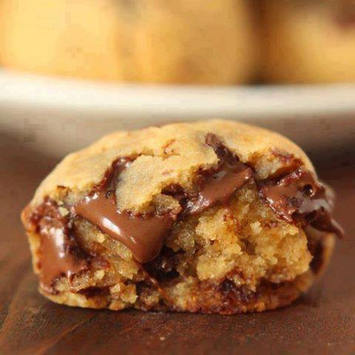
Peanut Butter Chocolate Chip Cookie Dough Bites
You won't believe it!!!!!!
NO FLOUR, NO OIL, NO WHITE SUGAR
Ingredients:
1 1/4 cups canned* chickpeas, well-rinsed and patted dry with a paper towel
2 teaspoons vanilla extract
1/2 cup + 2 tablespoons (165 grams) natural peanut butter (can use PB2 from gym to make healthier, check your labels)
1/4 cup (80 grams) honey (agave would be amazing too!)
1 teaspoon baking powder**
a pinch of salt if your peanut butter doesn’t have salt in it
1/2 cup (90 grams) chocolate chips
* My can was a 400 gram can, 240 grams without the water, and I used all but a few tablespoons
** If you need grain-free baking powder, you can use 1 part cream of tartar + 1 part baking soda + 2 parts arrowroot.

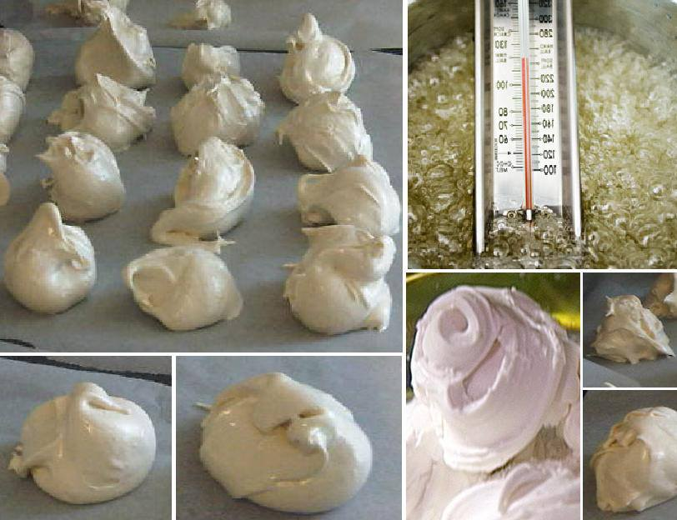
Divinity
Cook:
4 cups sugar
1 cup white Karo syrup
1 cup hot water
1 tsp salt
Cook until hard ball stage. (288 degrees)
Slowly pour over:
2 egg whites beaten stiff.
Beat and add 1 tsp vanilla…
Drop onto wax paper to harden.

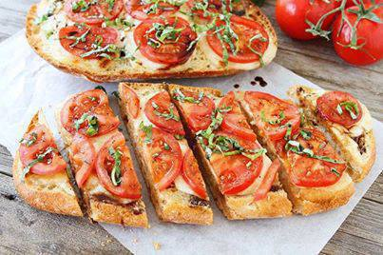
Caprese Garlic Bread
Garlic bread with fresh mozzarella cheese, tomatoes, basil, and a drizzle of balsamic! The best garlic bread you will ever eat!
1 loaf ciabatta bread, horizontally cut in half
4 tablespoons salted butter
3 cloves garlic, minced
12 oz. fresh mozzarella cheese, sliced
1/2 cup balsamic vinegar
2 medium tomatoes, sliced
Salt and freshly ground black pepper, to taste
1/3 cup chopped fresh basil
Directions:
1. Preheat oven to 400 degrees F. Place both sides of the baguette on a large baking sheet with the cut side up.
2. In a small bowl, combine butter and garlic and spread evenly on bread halves. Place the mozzarella cheese slices on top of the bread, making sure the cheese covers the bread completely. Bake the bread for 12-15 minutes or until the cheese is melted.
3. While the bread is in the oven, make the balsamic reduction. Place the balsamic vinegar in a small saucepan. Bring the vinegar to a boil, decrease the heat to low, and simmer, stirring occasionally, until the mixture is reduced by about half. This should only take about 5-7 minutes. Set aside.
4. Remove the bread from oven. Top the bread with tomato slices. Season with salt and pepper, to taste. Add the fresh basil and drizzle with balsamic reduction. Cut into slices and serve.

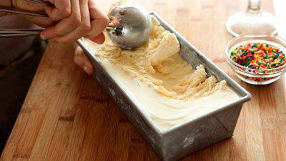
Vanilla Ice Cream Recipe
It'll take you just 10 minutes to prep this satisfying and delicious homemade vanilla ice cream.
The best part? You don't need one of those silly ice cream machines! Now that's magic, if you ask us.
Ingredients
1 can (14 ounces) sweetened condensed milk
2 teaspoons pure vanilla extract
2 tablespoons bourbon (optional)
2 cups cold heavy cream
Directions
In a medium bowl, stir together condensed milk, vanilla, and Bourbon, if desired.
In a large bowl, using an electric mixer, beat cream on high until stiff peaks form, 3 minutes.
With a rubber spatula, gently fold whipped cream into condensed milk mixture.
Pour into a 4 1/2-by-8 1/2-inch loaf pan. Freeze until firm, 6 hours.
Cook's Note: Freeze, covered, up to 1 week.

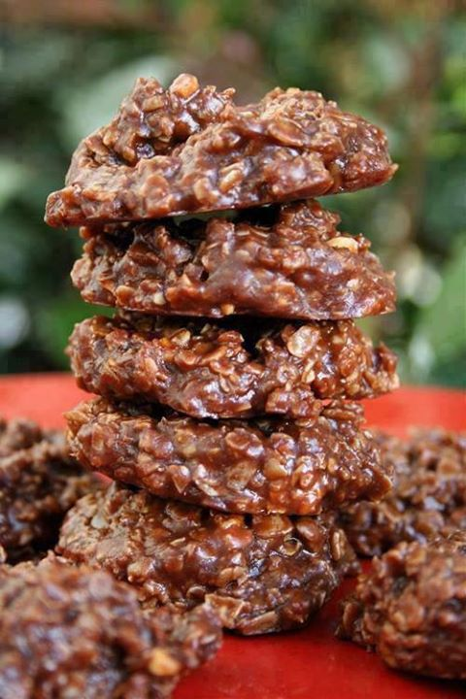
CHOCOLATE NO-BAKE OATMEAL COOKIES
Ingredients
1/2 cup butter or 1/2 cup margarine
2 cups sugar
1/2 cup milk
4 tablespoons cocoa
1/2 cup creamy peanut butter ( or chunky but is seems to make a more crumbly dry cookie)
2 teaspoons vanilla
3 -3 1/2 cups dry quick-cooking oats
Directions
Add the first four ingredients into a 4-quart sauce pan.
Bring to a rolling boil and hold for 1 minute.
Remove from heat.
Add peanut butter into the hot mixture and stir until melted.
Add in vanilla. (almond extract is good also, but I only use 1/2 teaspoon almond and 1 1/2 teaspoon vanilla).
Mix in the oats and drop by tablespoons onto wax paper.
Let cool until set.
*Please remember that even if you do follow the recipe exactly, it doesn't always turn out just right. I have had these not set up for me AND be hard and dry. But most of the time, the recipe is just right. I have also found that it makes a difference if you use quick cooking oats or old fashioned. In my experience it takes more old fashioned oats than quick cooking and I like the texture of the quick cooking better. When you make it a few hundred times like I have you learn a couple of things:) Also, Chunky peanut butter tends to make them more dry and crumbly.
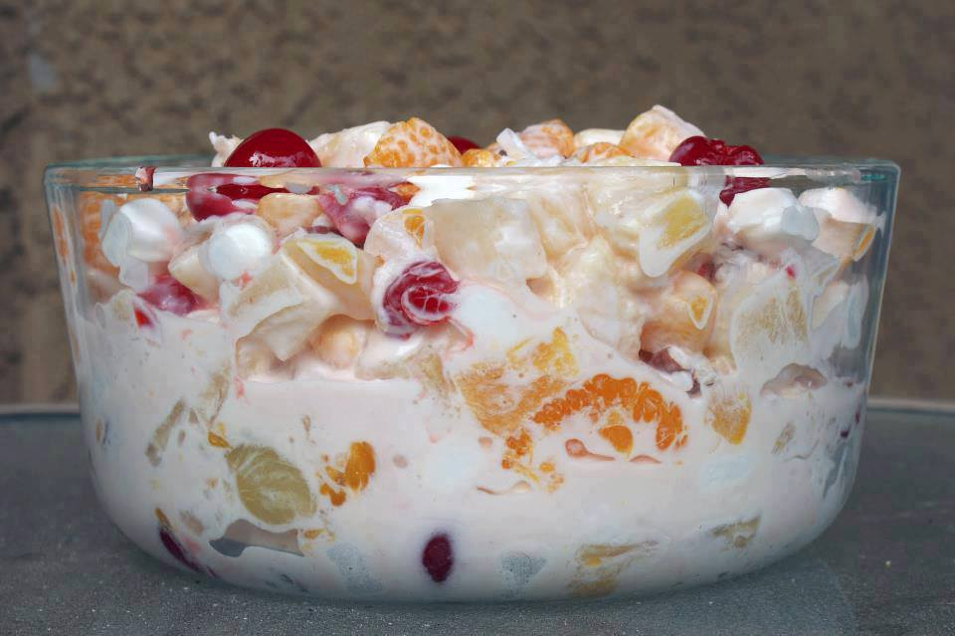
Fruit Salad - Ambrosia Style
Mandarin oranges, drained 2 (8 ounce) cans
Pineapple tidbits, drained 1 (16 ounce) can
Bananas, sliced 3
Miniature marshmallows 1 (12 ounce) bag
Sour cream, container 16 ounces
Maraschino cherries, sliced and drained (optional) 1 (6 ounce) can
Shredded coconut (optional) to taste

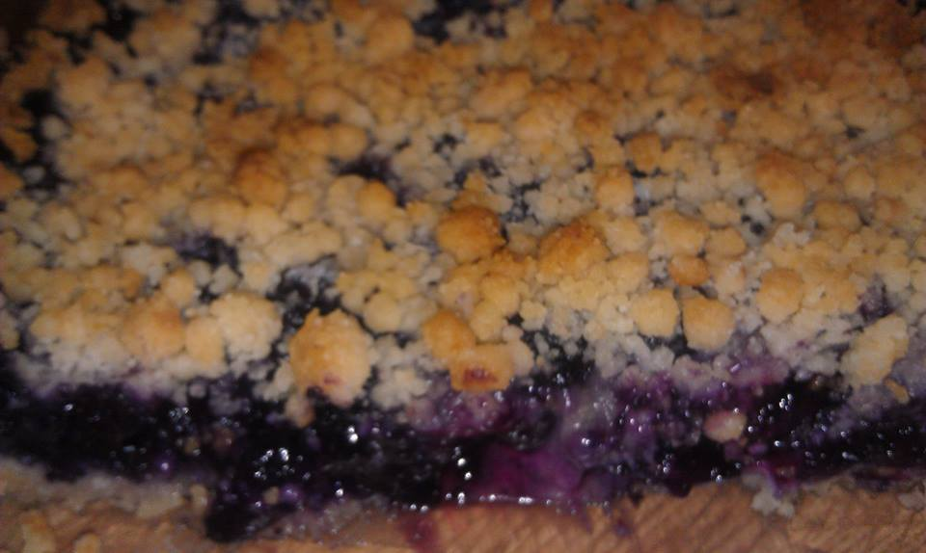
Blueberry Squares
Preheat oven to 375 degrees.
Mix 1:
1 1/2 cups flour
2 tsp. sugar
1/2 tsp. salt
Mix 2:
1/2 cup oil
2 tbsp. milk
Mix 3:
2 cups fresh blueberries
1/2 cup sugar
Some cornstarch
Combine mix 1 and mix 2 until crumbly. Reserve some for topping and pat the rest in the bottom and sides of a 7" x 11" glass baking dish.
Pour mix 3 into crust and crumble reserved crust mix on top. Bake at 375 degrees for 40 minutes or until crust is golden.
Note: Mix the oil and milk together before adding to dry ingredients or the crust will be greasy instead of like shortbread.

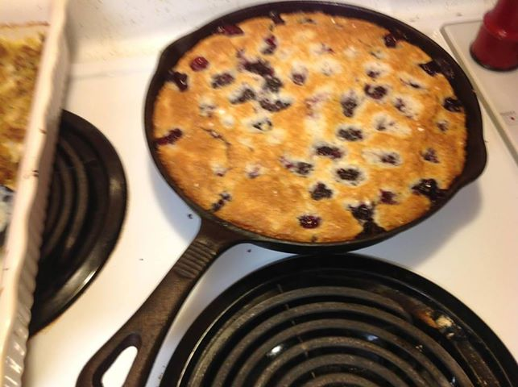
Poor Mans Cobbler!
Soo easy and delicious!
3 c of berries
1 c Milk
1 c self-rising flour
1 c sugar
Mix together milk sugar and flour. Pour a fourth of the mixture in a 8X8 in pan, sprinkle berries on top, pour in the remaining of mixture. Bake at 350 for 30 mins or until brown on top.. My grandma use to make this all the time and it has become a favorite in my home.

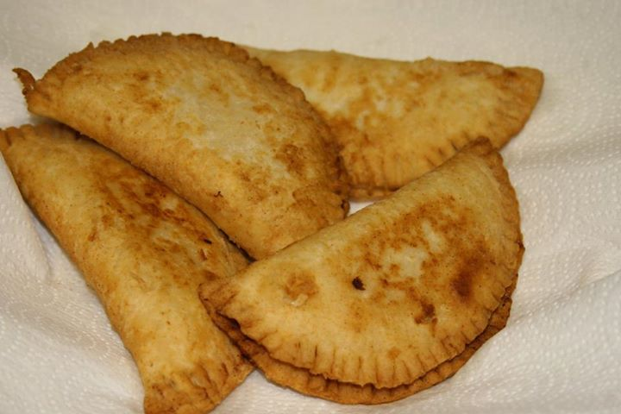
FRIED APPLE or PEACH PIES
Everybody loves them! And they are simple to make. These fried apple pies are made with refrigerated biscuits and dried apples/peaches. You can make your own biscuit dough or simply use refrigerated biscuits. If you make a double or triple batch to take to a gathering you will be the hit of the day! *The trick is making sure you get a good seal at the edge and don’t poke holes in them as you move them around. Don’t fry them too fast or the inside won’t get done.
Ingredients:
8 ounces dried apples or dried peaches
1 cup water
1/3 cup sugar
1 tablespoon butter
1 tsp. cinnamon or apple pie spice
1 can jumbo refrigerated flaky biscuits
vegetable oil, for frying
Preparation:
Combine apples and water in saucepan; bring to a boil. Cover, reduce heat, and simmer for 30 minutes or until tender. Remove from heat and let cool, mashing slightly if pieces are large. Stir in sugar and butter; set mixture aside.
**(If using fresh apples: For the filling: Add 2 TBS butter to a large saute pan and melt. Add 4 peeled, cored and chopped apples, sugar, cinnamon, and 1 tsp lemon juice and cook over medium heat until the apples are soft, about 15 minutes. Remove from the heat, mash slightly and cool.) Roll each biscuit into a 5-inch circle on a lightly floured surface. Place about 1 tablespoon apple mixture on half of each biscuit circle. To seal pies, dip fingers in water and moisten edges of circles. Fold in half, making sure edges are even. Using a fork dipped in flour, press edges firmly together to seal.
Pour oil to a depth of 1/2 inch into a heavy skillet, or use deep fryer. Fry pies in hot oil (370°) over medium-high heat until golden, turning once. Don't rush it because you want to make sure the biscuit is cooked completely through.
Drain well on paper towels.
Makes 10 pies.
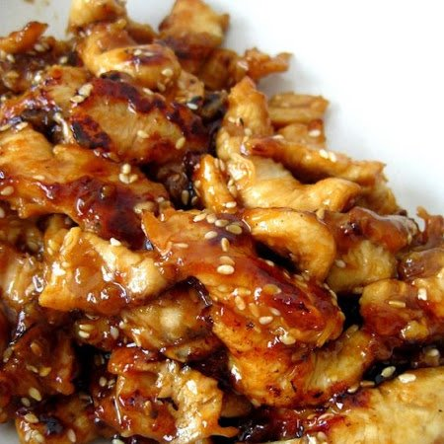
Crock-Pot Chicken Teriyaki
Ingredients
1 lbs chicken, diced
1 cup chicken broth
½ cup teriyaki sauce
⅓ cup brown sugar
3 garlic cloves, minced
Directions
1. Combine chicken broth, teriyaki sauce, brown sugar and garlic cloves in large bowl.
2. Add chicken to sauce, and toss to combine.
3. Pour chicken mixture into crock-pot.
4. Cook on low 4-6 hours, or until chicken is cooked through.
5. Serve over hot cooked rice and spoon extra sauce if desired.

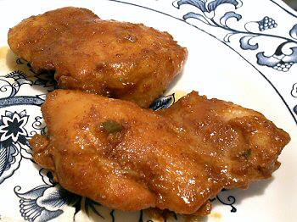
ALMOST "BOURBON" CHICKEN
8-10 boneless chicken thighs
5 tablespoons soy sauce
1/4 cup granular Splenda or equivalent liquid Splenda
2 green onions, chopped
2 cloves garlic, minced
1 tablespoon sesame oil
5 tablespoons water
1/2 teaspoon blackstrap molasses
2 tablespoons low carb ketchup
1/8 teaspoon liquid smoke
Put the chicken in a gallon zipper bag. Mix the remaining ingredients and pour over the chicken. Seal the bag, place in a baking pan and marinate in the refrigerator several hours or overnight, turning the bag occasionally. Cook the chicken on a grill or bake in a 9x13" pan at 350º for about an hour, turning the chicken over every 10 minutes, until the chicken is done. Makes 6 servings - Can be frozen
With granular Splenda:
Per Serving: 148 Calories; 6g Fat; 19g Protein; 4g Carbohydrate; trace Dietary Fiber; 4g Net Carbs
With liquid Splenda:
Per Serving: 144 Calories; 6g Fat; 19g Protein; 3g Carbohydrate; trace Dietary Fiber; 3g Net Carbs
After realizing how much my Seoul Chicken reminded me of the Bourbon Chicken that they sell in the food court at the mall, I decided to add a few more ingredients to try to get the flavor a bit more like it. This doesn't have the sticky sauce of the original, but the flavor is similar. Actually, I think the Seoul Chicken is close enough and I'll probably just keep making that since it has fewer carbs and is simpler to make, but I may add a little extra sweetener. I liked using boneless thighs for this because they're easier to eat and the marinade penetrates the meat better than when on the bone.

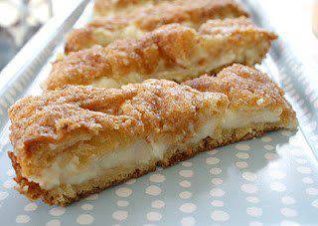
Cream Cheese Bars
We found this recipe and it had no name...
I only know it should be illegal!!!
Ingredients:
-2 cans Pillsbury butter crescent rolls
-2 (8oz) packages cream cheese (softened)
-1 cup sugar
-1 teaspoon vanilla
-1/4 cup butter (melted)
-Cinnamon & sugar (I used about 1/4 cup sugar and 1 tbs cinnamon)
Instructions:
Unroll and spread 1 can crescent rolls on bottom of un-greased pan. Combine softened cream cheese, sugar, and vanilla. Spread mixture over crescent rolls. Unroll and spread remaining crescent rolls over mixture. Spread melted butter over the top and sprinkle with cinnamon and sugar. Bake at 350 degrees for 20-30 minutes.

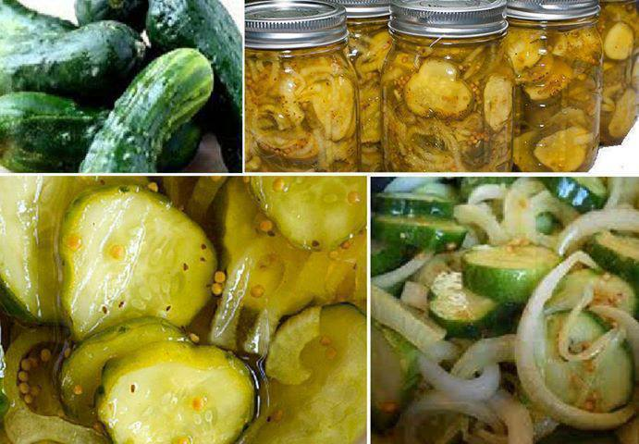
***Bread and Butter Pickles***
4 pounds cucumbers, sliced
8 small onions, sliced
1/2 cup canning salt
5 cups sugar
4 cups apple cider vinegar
2 tablespoons mustard seed
2 teaspoons celery seed
1-1/2 teaspoons ground turmeric
1/2 teaspoon ground cloves
Wash cucumbers and cut off the ends. Slice crosswise into 1/8-inch slices. Toss in a large bowl with the salt and onion slices; cover with about 4 to 6 cups of ice cubes. Cover and let stand for 4 hours or refrigerate overnight. Drain the cucumber mixture.
In a Dutch oven, combine the sugar, vinegar, mustard and celery seed, turmeric and cloves; bring to a gentle boil. Add cucumber mixture; return to boil. Remove from the
heat.
Ladle hot mixtures into hot, sterilized pint jars, leave ½ inch from the top. Remove air bubbles with a knife, wipe rim of jar, seal with hot sterile lid and ring. Process in boiling water bath 15 minutes. Remove jars, let cool over night, label and store in a dark cool place. Makes 7 pints.
Variations:
Add a hot pepper or two to each jar.
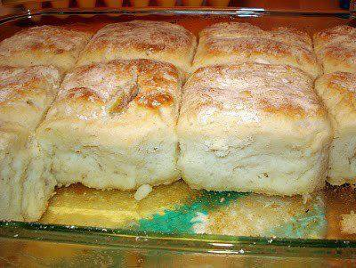
7 Up Biscuits
Bisquick, sour cream, 7-up and butter!.... These are excellent!!!! So easy and soooo good! Recipe is hard to find so here it is:
4 cups Bisquick
1 cup sour cream
1 cup 7-up
1/2 cup melted butter
Mix bisquick, sour cream and 7 up. Dough will be very soft - don't worry Knead and fold dough until coated with your baking mix. Pat dough out and cut biscuits using a round biscuit / cookie cutter. Melt butter in bottom of cookie sheet pan or 9x13 casserole dish. Place biscuits on top of melted butter and bake for 12-15 minutes or until brown at 425 degrees,

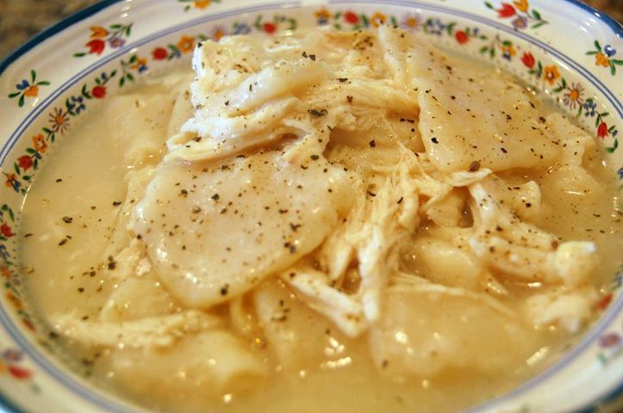
Cracker Barrel chicken n' dumplins
Ingredients:
2 cups Flour
½ teaspoons Baking Powder
1 pinch Salt
2 Tablespoons Butter
1 Cup butterMilk, A Bit Less Than A Full Cup (you can use regular milk if needed)
2 quarts Chicken Broth
3 cups Cooked Chicken
Preparation Instructions:
In a bowl, combine the flour, baking powder and salt. Cut the butter into the dry ingredients with a fork or pastry blender. Stir in the milk, mixing with a fork until the dough forms a ball.
Heavily flour a work surface. You’ll need a rolling pin and something to cut the dumplings with. I like to use a pizza cutter. I also like to use a small spatula to lift the dumplings off the cutting surface.
Roll the dough out thin with a heavily floured rolling pin. Dip your cutter in flour and cut the dumplings in squares about 2″x2″. It’s okay for them not to be exact. Just eye ball it. Some will be bigger, some smaller, some shaped funny.
Use the floured spatula to put them on a heavily floured plate. Just keep flouring between the layers of dumplings.
To cook them, bring the broth to a boil. Drop the dumplings in one at a time, stirring while you add them. The extra flour on them will help thicken the broth. Cook them for about 15-20 minutes or until they not doughy tasting. Add the cooked chicken to the pot and you’re done!

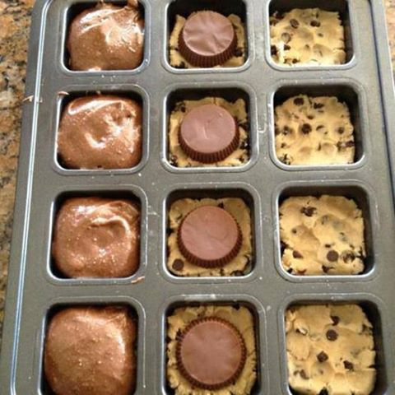
Chocolate Chip Reeses Brownies
Preheat oven to 350; smoosh refrigerated cookie dough into the bottom of each well. Place Reese cup upside down on top of cookie dough (or an Oreo!). Top with prepared box brownie mix, filling 3/4 full. Bake for 18 minutes! HEAVEN!

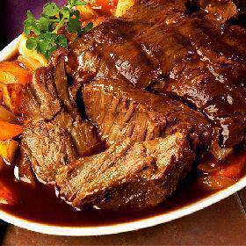
3 Envelope Roast
Ingredients:
3 pound beef roast such as chuck roast
1 envelope of dry Italian salad dressing mix
1 envelope of dry ranch salad dressing mix
1 envelope of dry brown gravy mix
2 cups water
Instructions :
Put the water in a measuring cup that is larger then the amount of water you are using. Now add and mix all three envelopes to the water. Mix until blended completely.
Brown the roast (if desired). Add the meat to your cooker. Pour the water, salad dressing mixture over the roast. In the slow cooker cook it on high for about 4 hours on low about 8 hours.
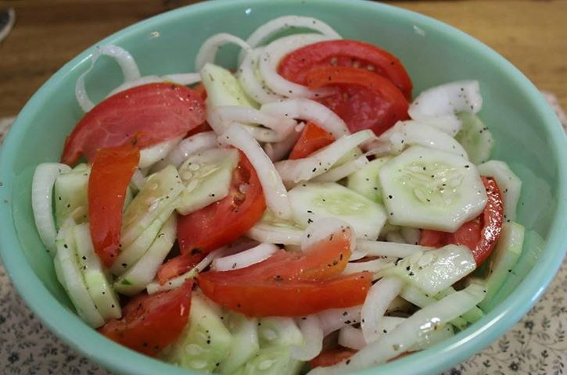
Grandma's Cucumber Salad
3 Med. Cucumbers Peeled and Sliced 1/4"
1 Med. Onion sliced and separate into rings
3 Med. tomatoes cut into wedges
1/2 C. Vinegar
1/4 C. Sugar
1 C. water
1/4 C. olive oil
2 tsp.salt
1 tsp. ground pepper
Combine all in a large bowl, toss making sure everything is coated well. Refrigerate for at least 2 hrs before serving

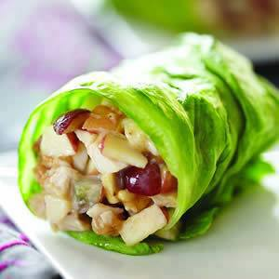
Chicken Apple Wraps
Ingredients
1/2 cup chopped cooked chicken breast
3 tablespoons chopped Fuji apple
2 tablespoons chopped black or red grapes
2 tablespoons Crunchy Peanut Butter
1 tablespoon lite mayonnaise (or greek yogurt)
2 teaspoons honey
Iceberg lettuce
Preparation
Chop chicken meat and fruit, mix in bowl. Mix in peanut butter, mayonnaise and honey.
Spoon into open lettuce leaf, roll and serve

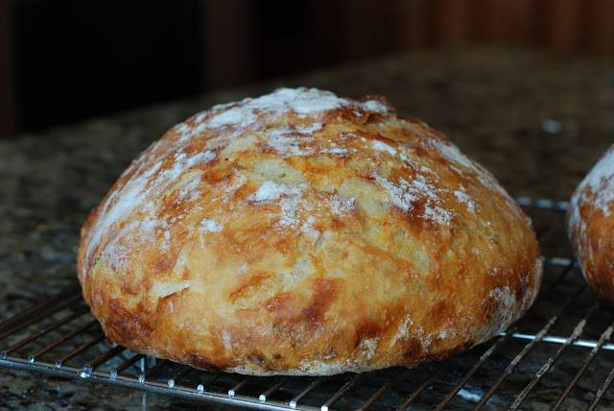
Crusty Bread (simply so good)
3 cups unbleached all purpose flour
1 3/4 teaspoons salt
1/2 teaspoon Instant or Rapid-rise yeast
1 1/2 cups water
In a large mixing bowl, whisk together flour, salt and yeast. Add water and mix until a shaggy mixture forms. Cover bowl with plastic wrap and set aside for 12 - 18 hours. Overnight works great. Heat oven to 450 degrees. When the oven has reached 450 degrees place a cast iron pot with a lid in the oven and heat the pot for 30 minutes. Meanwhile, pour dough onto a heavily floured surface and shape into a ball. Cover with plastic wrap and let set while the pot is heating. Remove hot pot from the oven and drop in the dough. Cover and return to oven for 30 minutes. After 30 minutes remove the lid and bake an additional 15 minutes. Remove bread from oven and place on a cooling rack to cool.
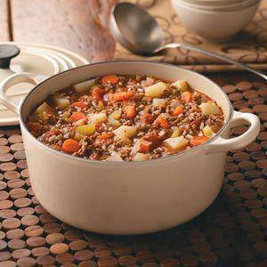
HAMBURGER STEW
Note: Serve with buttered cornbread.
Ingredients
2 pounds ground beef
2 medium yellow onions, chopped
4 cans (14-1/2 ounces each) stewed tomatoes
8 medium carrots, thinly sliced
4 celery ribs, thinly sliced
2 medium potatoes, peeled and cubed
2 cups water
1/2 cup uncooked long grain rice
1 to 2 tablespoons salt
1 to 2 teaspoons pepper
Directions
Cook beef and onions over medium heat; drain. Add tomatoes, carrots, celery, potatoes, water, rice, salt and pepper; bring to a boil. Reduce heat; cover and simmer for 30 minutes until vegetables and rice are tender. Uncover; simmer 20-30 minutes longer or until thickened!
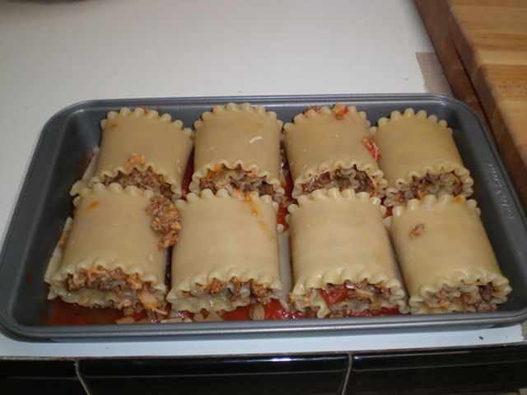
Lasagna Rolls: 11x 7 pan
Oven 375 degrees for 30 mins uncover and go 5 or so more minutes till cheese is brown
8 lasagna noodles cooked to AL den ta
1/2 lb hamburger (I mixed sausage and gr beef)
1 small onion chopped
1 Jar spaghetti sauce of your liking
1 sm can mushrooms chopped
salt and pepper to taste
1 1/2 tsp minced garlic or powder (whatever u like)
dash of crushed red pepper flakes.
2 c mozzarella finely shredded
cook meat with onion garlic, 1/3 can of chopped mushrooms, salt, pepper, red flakes. Drain when done, add 1/3 jar or enough to bring meat together so it sticks together. Add 1 to 1 1/2 cups of cheese after meat is cool a bit. Spread a little sauce on bottom of pan then prepare rolls by doing the following:
Lay noodles out and lay an equal portion of meat on each noodle and roll carefully. This is the pain part. If u roll to tight the meat falls out. lol dump the rest of the sauce on top of the noodles and cheese. cover loosely with foil for 30 mins then uncover to brown and heat through. ENJOY..

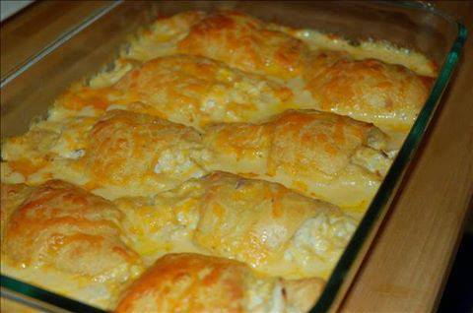
Chicken Crescent Rolls
2 cans of low fat refrigerator crescents
1 can of healthy low sodium cream of chicken soup (26oz)
1 cup fat free cheddar cheese
2 boneless skinless chicken breast
I boil my chicken breast then shred, roll out each individual crescent, place about a Tbsp of shredded chicken in center and roll it up.
Bake on 350 for about 5 minutes until just starting to turn golden. Pour Cream of chicken over the top bake an additional 10 min top with cheddar cheese and bake for 10 more minutes.

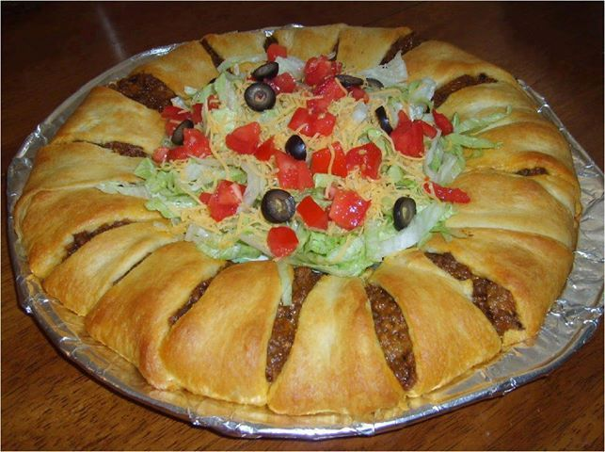
Crescent Roll Taco Bake
2 crescent roll tubes
1 LB ground beef (or ground turkey)
1 packet of taco seasoning
1 1/2 cups grated cheddar cheese
Shredded lettuce
1 or 2 diced tomatoes depending on size
1/2 small can sliced olives if desired
Sour cream optional
sliced avacado optional
Lay out the two tubes of crescent pastry, thick sides in. Use some of the left over crescent rolls to to make the center a bit thicker.
Brown beef and add taco seasoning.
Lay beef in a circle inside of the laid out crescent rolls
Add cheese to the top
Pull over crescent rolls and tuck in under meat and cheese.
Add cheese, lettuce, tomato, black olives, sour cream or whatever you desire for your tacos, in the middle.
Follow cook time on the pack of crescent rolls, and once it's done, you're good to go!

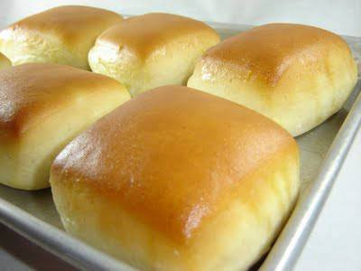
Texas Roadhouse Rolls - "YES" The Real Recipe ~
4 tsp. active dry yeast
1/2 c. warm water
2 c. milk, scalded and cooled to lukewarm
3 Tbl. of melted butter, slightly cooled
1/2 c. sugar
2 quarts all purpose flour (7-8 cups)
2 whole eggs
2 tsp. salt
Dissolve yeast in warm water with a teaspoon of sugar; let stand until frothy. Combine yeast mixture, milk, 1/2 cup sugar and enough flour to make a medium batter (about the consistency of pancake batter). Beat thoroughly. Add melted butter, eggs and salt. Beat well. Add enough flour to form a soft dough. Sprinkle a small amount of flour onto counter and let dough rest. Meanwhile, grease a large bowl. Knead dough until smooth and satiny and put in greased bowl; turn over to grease top. (I used the dough hook on my Kitchen-
Aid to knead this for about 4-5 minutes). Cover and let rise in a warm place until double in bulk. Punch down. Turn out onto a floured board. Divide into portions for shaping; let rest 10 minutes. Shape dough into desired forms. Place on greased baking sheets. Let rise until doubled.
Bake at 350 degrees for 10-15 minutes or until golden brown. Baste immediately with butter. Yield: 5 to 6 dozen. Serve with Cinnamon Honey Butter.
*Extra Tips: Shape the rolls into a rectangle, about 1/2-inch thick, then fold it in half, making it an inch thick. Roll over the dough to seal the two halves and using a dough scraper, cut them into squares and place them on the baking sheet
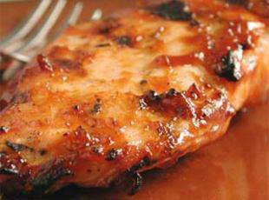
Sweet Baby Ray's Crockpot Chicken
4-6 chicken breast
1 btl Sweet Baby Ray's sauce
1/4 c vinegar
1 tsp red pepper flakes
1/4 c brown sugar
1 tsp garlic powder
Mix everything but chicken
Place chicken in crockpot (frozen is ok)
Pour sauce mixture over chicken
Cook on low 4-6 hours

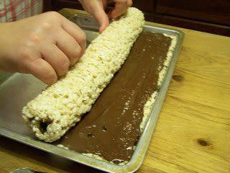
Rice Krispies Rollups
¼ cup butter, melted
10½ ounces mini marshmallows
5½ cups Rice Krispies
1½ cups milk chocolate chips
½ cup peanut butter
Melt butter in a 6 quart kettle,add marshmallows. Melt completely over low heat. Add the Rice Krispies.
Mix well. Spread evenly into a greased 10½ x 15½ baking sheet. In a microwave safe bowl combine chocolate chips and peanut butter. Melt at 1 minute intervals until completely melted, stirring after each minute. Spread on top of Rice Krispies mixture. Let set in a cool place till chocolate mixture sets up. Be careful not to let the chocolate get too hard, it will not make a neat roll if you do.
Loosen all around with a metal spatula. Roll, starting on the long side. Sprinkle the roll with seasonal sprinkles if desired. Slice and enjoy! Can be wrapped in Saran Wrap for storage if needed.
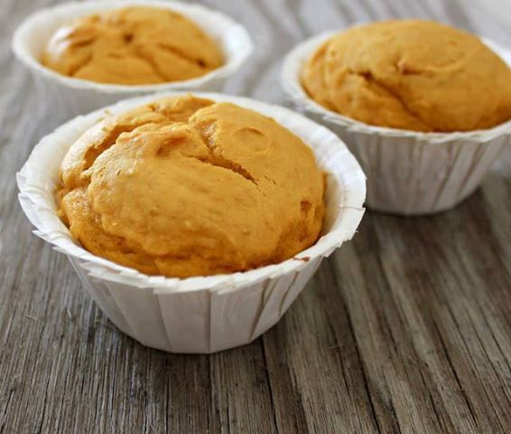
2 INGREDIENT PUMPKIN MUFFINS!!!! OMG!!!!
(When you have a cheat day)
1 box Classic Yellow Cake Mix
1 can (15 oz) Pure Pumpkin
No oil, no eggs, no water, nothing else
Combine both ingredients, pour into muffin tin and bake at 350 degrees for 20-25 minutes.

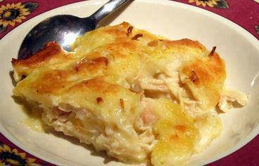
Chicken and Dumpling Casserole
2 chicken breasts, cooked and shredded ( you can use a store bought rotisserie chicken)
2 cups chicken broth
1/2 stick of butter
2 cups Bisquick
2 cups whole milk
1 can cream of chicken soup (the herbed cream of chicken soup if you can find it)
3 teaspoons of chicken granules (Bullion)
1/2 teaspoon dried sage
1 teaspoon black pepper
1/2 teaspoon of salt or more to taste
Directions:
Preheat your oven to 350 degrees.
Layer 1 - Melt 1/2 stick of butter in 9 x 13 casserole dish. Spread the shredded chicken over butter. Sprinkle black pepper and dried sage over this layer. Again do not stir.
Layer 2 - In a small bowl, mix the milk and Bisquick. Slowly pour evenly all over chicken. Again do not stir.
Layer 3 - In medium bowl, whisk together 2 cups of chicken broth, the chicken granules and the chicken soup. Once all mixed, slowly pour over the Bisquick layer. Again do not Stir.
Bake the casserole for 30-40 minutes, or until the top is golden brown
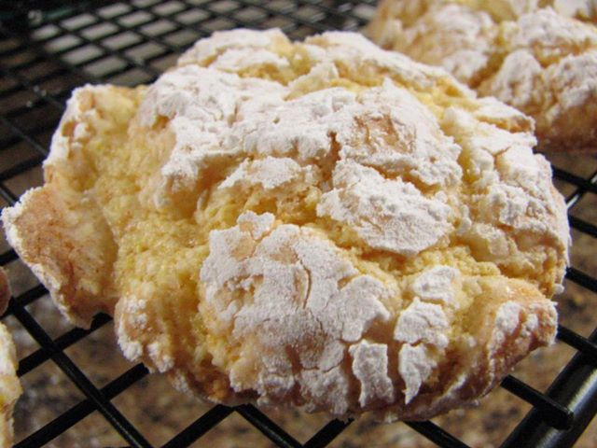
COOL WHIP COOKIES-
EASIEST COOKIE EVER! 1 box cake mix (any flavor- chocolate, red velvet, lemon, etc.), 1 tub Cool Whip (8 oz), 1 egg. Mix ingredients. Drop spoonfuls into powdered sugar to coat. Bake at 350 for 12 mins cool before removing

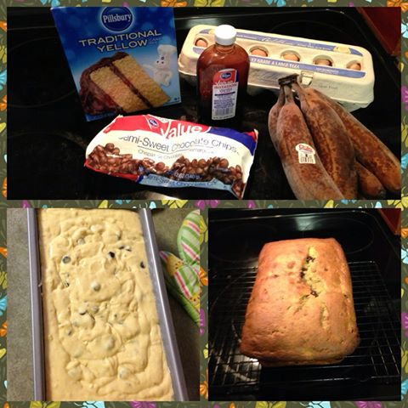
Banana Bread
The most easiest banana bread recipe ever! Box yellow cake mix, 5 ripe bananas, 3 eggs, teaspoon vanilla! Mix ingredients in the mixer until smooth! Bake 350 for 1 hour, spray bread pan! Sooo good!

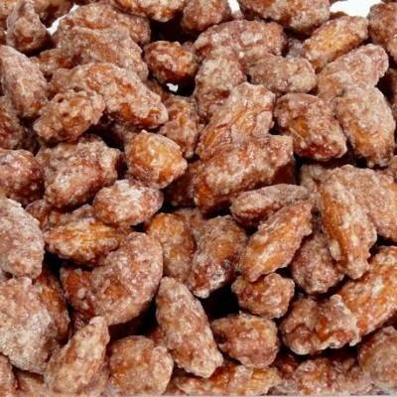
Crock Pot Cinnamon Almonds
Ingredients:
1 1/2 C. Sugar
1 1/2 C. Brown Sugar
3 Tbsp. Cinnamon
1/8 tsp. Salt
1 Egg White
2 tsp. vanilla
3 Cups Almonds
1/4 C. Water
Directions:
In a medium sized bowl, mix together sugars, cinnamon, and salt. Set aside. In another medium sized bowl, whisk the egg white and vanilla until it’s a little frothy. Add almonds. Make sure the almonds are thoroughly coated in the egg white mixture. Add cinnamon mixture to the almonds and toss until coated. Thoroughly spray with the stoneware of your crock pot with non-stick cooking spray and add the mixture of almonds and sugars.
Cook on low ( with the lid on) 3-4 hours stirring every 20 minutes. In the last hour, add the 1/4 C. of water and stir well. This ensures a crunchy yummy coating. (*make sure after you’ve added the water that you continue to cook the nuts for another 45 minutes to an hour.) You have to stir really well, especially as it gets later in the cooking process.
Line a baking sheet with parchment and spread the almonds flat to cool. The almonds will be sticky at this point, so make sure you separate them a little and have no large mounds.

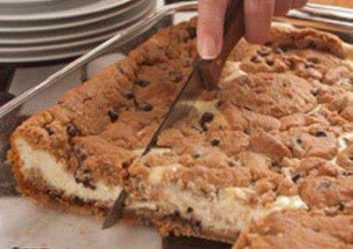
Chocolate Chip Cookie Cheesecake
Ingredients
3 (8-ounce) packages cream cheese, softened
3 eggs
3/4 cup sugar
1 teaspoon vanilla extract
2 (16.5-ounce) rolls refrigerator chocolate chip cookie dough
Instructions
Preheat oven to 350 degrees F.
In a large bowl, beat together cream cheese, eggs, sugar, and vanilla extract until well mixed; set aside.
Slice cookie dough rolls into 1/4-inch slices. Arrange slices from one roll on bottom of a greased 9- x 13-inch glass baking dish; press together so there are no holes in dough. Spoon cream cheese mixture evenly over dough; top with remaining slices of cookie dough.
Bake 45 to 50 minutes, or until golden and center is slightly firm.
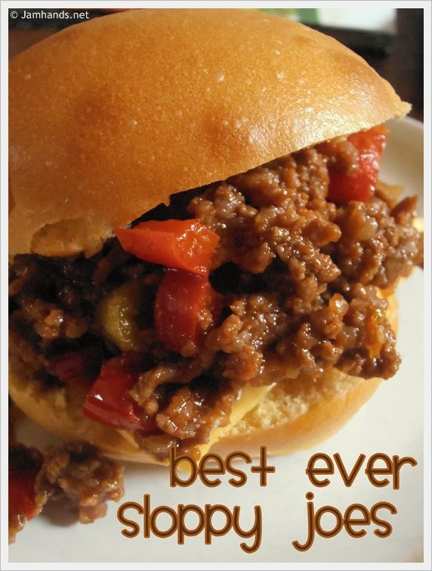

Best Ever Sloppy Joes
yield: MAKES SEVERAL

ingredients:
1 lb. ground beef
1 medium onion
1 Tbsp. mustard
1 Tbsp. Worcestershire sauce
1 Tbsp. sugar
1 Tbsp. vinegar
3/4 c. ketchup
1 tsp. salt
1/2 c. chopped green or red bell peppers
1/2 c. chopped celery

directions:
1. Cook ground beef and chopped onion. Drain fat off meat. Add back to large pan. Add remaining ingredients. Mix. Reduce heat to low and cook 40 minutes. Serve with fresh bakery buns.

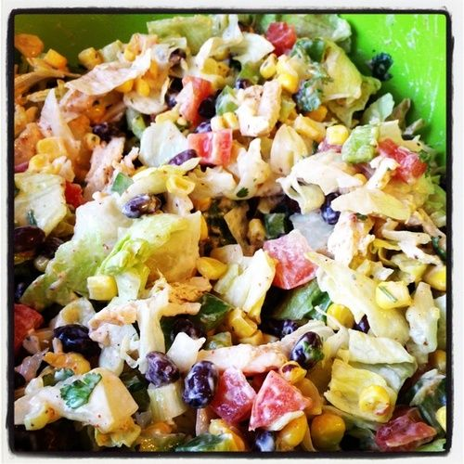
Chicken Taco salad
that’s HEALTHY!
There’s black beans, corn, green peppers, tomatoes, cilantro, green onions, chicken, avocado ; tortilla chips. All tossed together with a taco ranch dressing made with Greek yogurt.

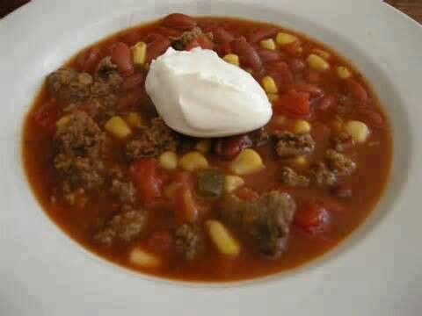
TACO SOUP
Ingredients
Inspired by budgetbytes.com
- 1.25lb of ground turkey (or ground beef, if you prefer)
- 3 tbsp of taco seasoning
- 1 tbsp of olive oil
- 3 cloves of garlic, minced
- 1 packet of ranch seasoning mix, such as Hidden Valley
- 2 14.5 cans of spicy red pepper diced tomatoes
- 1 can of pinto beans, drained and rinsed
- 1 cup of frozen corn kernels
- 1 small onion, chopped
- 1 jalapeno, seeded and diced
- 1 4oz can of diced green chilis
- 1/2 cup of beer (I suggest dark beer – I used Sierra Nevada Torpedo IPA)
- 3 tbsp of chopped cilantro
- Shredded cheese and sour cream for garnishment
Directions

1. In a large pot, heat olive oil. Add the ground turkey, onion, jalapeno and garlic and brown the meat.
2. Add the beans, diced chilis, diced tomatoes and beer and mix well.
3. Add the taco seasoning and ranch packet. Mix well.
4. Add the cilantro and frozen corn and mix well.
5. Simmer for 10-15 minutes

Serve with sour cream, cheese and garnish with extra cilantro, if you love cilantro as I do.

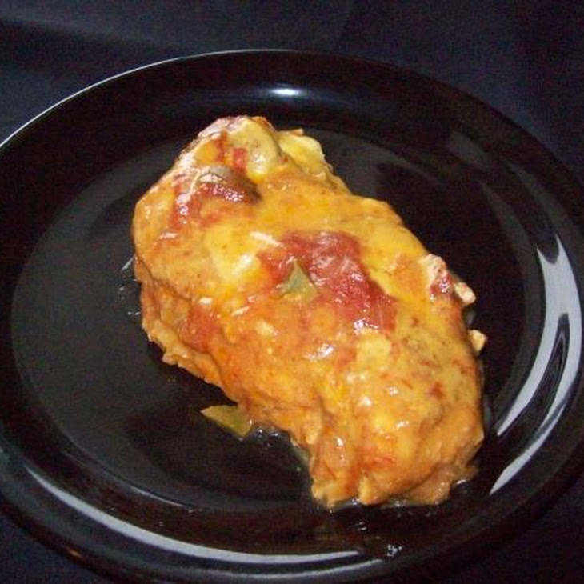
Slow Cooker Salsa Chicken
4 boneless skinless chicken breasts
1 cup salsa
1 (1 1/4 ounce) package taco seasoning
1 (10 1/2 ounce) can low-fat cream of chicken soup
1/2 cup reduced-fat sour cream

Directions:

1. Place chicken in slow cooker and sprinkle with taco seasoning.
2. Pour salsa and soup over chicken.
3. Cook on low 6-8 hours.
4. Remove from heat and stir in sour cream.
5. Serve over rice.

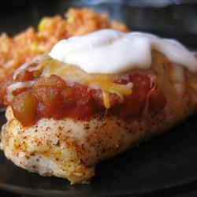
Oven Baked Salsa Chicken
4 skinless, boneless chicken breast halves
4 teaspoons taco seasoning mix
1 cup salsa
1 cup shredded Cheddar cheese
2 tablespoons sour cream (optional)

Directions
Preheat oven to 375 degrees F (190 degrees C)
Place chicken breasts in a lightly greased 9x13 inch baking dish. Sprinkle taco seasoning on both sides of chicken breasts, and pour salsa over all.
Bake at 375 degrees F (190 degrees C) for 25 to 35 minutes, or until chicken is tender and juicy and its juices run clear.
Sprinkle chicken evenly with cheese, and continue baking for an additional 3 to 5 minutes, or until cheese is melted and bubbly. Top with sour cream if desired, and serve.r 30 minutes in the preheated oven, or until cheeses are melted.

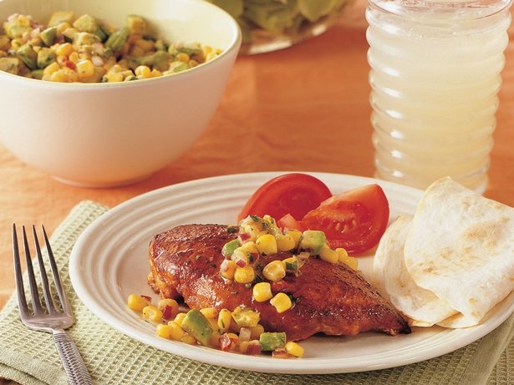
Taco chicken served with corn salsa
1 envelope (1 1/4 ounces) taco seasoning mix
4 boneless, skinless chicken breast halves (1 1/4 pounds)
2 tablespoons vegetable oil
1 can (11 ounces) whole kernel corn with red and green peppers, drained
1 medium avocado, pitted, peeled and chopped
2 tablespoons finely chopped red onion
2 tablespoons chopped fresh cilantro
1 tablespoon lime juice
1 teaspoon honey

- Reserve 2 teaspoons of the taco seasoning mix in medium bowl. Coat chicken with remaining taco seasoning mix.
- Heat oil in 12-inch skillet over medium heat. Cook chicken in oil 3 to 5 minutes, turning once, until brown. Reduce heat to medium-low. Cook about 8 minutes, turning once, until chicken is no longer pink when centers of thickest pieces are cut.
3 ) While chicken is cooking, add remaining ingredients to reserved taco seasoning mix; toss gently. Serve salsa with chicken.
EXPERT TIPS
You can make the salsa ahead of time, but be sure to add the avocado just before serving to preserve its color and texture.

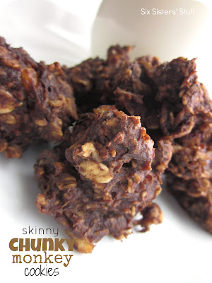
Skinny Chunky Monkey Cookies Recipe:
(Makes 30 cookies)
Ingredients:
3 ripe bananas
2 cups old-fashioned oats
1/4 cup creamy peanut butter
1/4 cup unsweetened cocoa powder
1/3 cup unsweetened applesauce
1 tsp. vanilla extract
Directions:
Preheat oven to 350°F. Mash bananas in a large bowl, then stir in remaining ingredients. Let batter stand for approximately 20 minutes, then drop by teaspoonfuls onto ungreased cookie sheet. Bake 10-12 minutes.
Freezing Directions:
Cool completely, then place cookies in a freezer bag. Seal, label, and freeze.

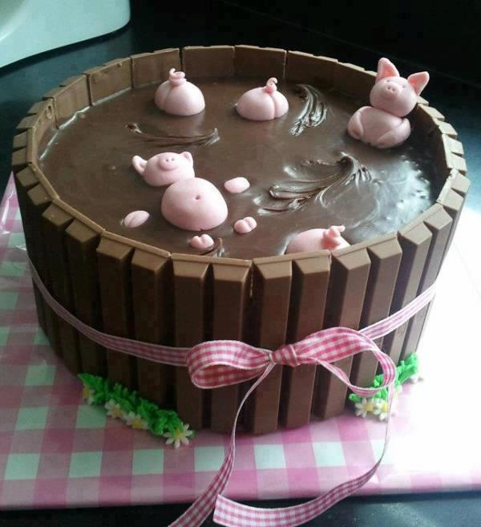
Chocolate Mud Cake ( Recipe )
It’s moist and choclatey. The recipe makes two 10-11 inch cakes.
Serves: 16-20 Preparation time: 15 mins Cooking time: 30-35
1 Cup butter (room temperature)
1 Cup Powdered sugar
1 Cup light brown sugar
8 medium eggs (room temperature)
1 1/2 Cups self-raising flour
1/2 Cup cocoa powder
2 teaspoons bicarbonate of soda
generous pinch of salt
10 tablespoons sour cream
2 teaspoons good vanilla extract
Decor: Three 4.5-ounce Giant Kit Kat Bars (you'll need 36 Kit Kat sticks total)
Ribbon
Method: Pre-heat the oven to 350F and prepare two 10 or 11 inch cake tins with baking parchment. Sift dry ingredients together. Cream butter and sugar until pale and fluffy. Gradually beat in the eggs. If it looks like curdling add two tablespoons from the flour mixture. Fold in the flour mixture, and creme fraiche, alternating between the two -starting and ending with the flour. Divide evenly between tins and gently encourage the mix to the sides. Bake for 30-35 mins, until they smell ready and a toothpick comes out clean. Let cool 5 mins in tins, then turn on to a wire rack to cool.
Here is a quick and easy recipe for a Choc Ganache Icing.
Ingredients
1 Cup dark cooking chocolate, chopped
1/3 cup cream
Method: Combine chocolate and cream in a heatproof bowl over a saucepan of simmering water. Stir with a metal spoon until smooth. Remove bowl from heat. Set aside at room temperature to cool, stirring occasionally, until ganache is thick and spreadable.
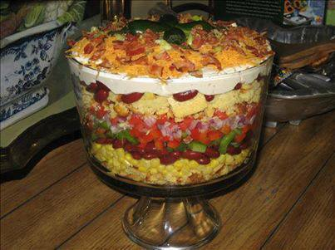
Southwestern Cornbread Layered Salad
1 (1 ounce) Package Ranch Dressing Mix
1 Cup Mayonnaise
1 Cup Sour cream
1 (8 ounce) Package Cornbread, prepared
2 (15 ounce) Cans Whole Kernel Corn, drained
2 (15 ounce) Cans Red Kidney Beans, rinsed and drained
4 Roma Tomatoes, chopped
1 Red Bell Pepper, chopped
1 Green Bell Pepper, chopped
1 Small Red Onion, chopped
4 Green Onions, sliced
16 ounces Cheddar Cheese, shredded
18 slices Bacon, cooked and crumbled
Directions:
Prepare 8" pan of cornbread according to package directions. When cooled, cut into large cubes and toast in 375 degree oven for about 10 minutes. Remove from oven to cool. Set aside and prepare dressing using first three ingredients.
Using 1/2 of cornbread, break into smaller chunks and place in glass serving dish. Begin layering 1/2 of the ingredients (except cheese, bacon & dressing)in order and repeat, beginning again with remaining cornbread. Spread top layer with dressing and top with cheese and bacon crumbles. Garnish with green onion tops or small sweet jalapenos, halved & seeded. Refrigerate until serving time.

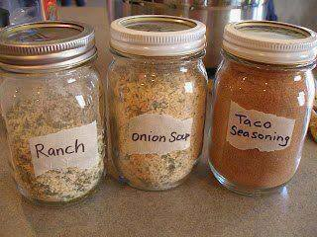
Taco, Ranch, and Onion Mixes
Make your own Ranch, Dry Onion Soup Mix and Taco Seasoning and store in small mason jars....This is soooo much HEALTHIER than those you buy at the store!! They contain a TON of stuff that is not good for you!!
Taco Seasoning:
1/2 cup chili powder
1/4 cup onion powder
1/8 cup ground cumin
1 tablespoon garlic powder
1 tablespoon paprika
1 tablespoon sea salt
Put ingredients into a jar and shake.
Dry Onion Soup Mix:
2/3 cup dried, minced onion
3 teaspoons parsley flakes
2 teaspoons onion powder
2 teaspoons turmeric
1 teaspoon celery salt
1 teaspoon sea salt
1 teaspoon sugar
1/2 teaspoon ground pepper
Mix all ingredients in a jar, then give the jar a good shake. I’d recommend shaking the jar to mix the ingredients well before each use. Use 4 tablespoons in a recipe in place of 1 packet of onion soup mix. Store this in a dry, cool place.
Ranch:
5 tablespoons dried minced onions
7 teaspoons parsley flakes
4 teaspoons salt
1 teaspoon garlic powder
Mix together and store in an air tight container.
For dressing: Mix 2 tablespoons dry mix with 1 cup mayonnaise and 1 cup buttermilk or sour cream.
For dip: Mix 2 tablespoons dry mix with 2 cups sour cream or Greek Yogurt.
Mix up a few hours before serving, so the flavors all blend.

CRACK ROLLS
(You can't eat just one. ~Glenda)
1 loaf (16 ounces) thinly sliced white bread, crusts removed
1 package (8 ounces) cream cheese, softened
3/4 cup confectioners sugar
1 cup sugar
1-1/2 teaspoon ground cinnamon
3/4 cup butter, melted
Flatten bread with a rolling-pin. In a bowl, combine cream cheese and confectioners’ sugar. In another bowl, combine sugar and cinnamon; set aside. Spread about 1 tablespoon of cheese mixture on each slice of bread. Roll up, jelly roll style. Dip in melted butter, then in cinnamon-sugar. Place on an ungreased baking sheet.
Bake at 350° for 20 minutes or until golden brown.
Yield: 16 roll-ups. Good warm or cold. ADDICTING!

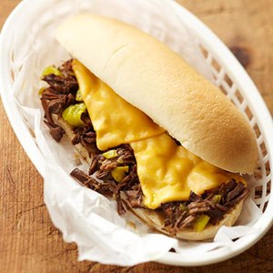
PHILLY STEAK SANDWICH
Ingredients
1 2 1/2 - 3 pound boneless beef chuck pot roast
1 cup chopped onion (1 large)
1/4 cup Worcestershire sauce
1 tablespoon instant beef bouillon granules
2 cloves garlic, minced
1 teaspoon dried oregano, crushed
1/2 teaspoon dried basil, crushed
1/2 teaspoon dried thyme, crushed
1/2 cup chopped pepperoncini
8 hoagie buns or kaiser rolls, split and toasted
8 slices American cheese
Directions
1. Trim fat from meat. Cut into 1-inch pieces. In a 3 1/2- or 4-quart slow cooker, combine meat, onion, Worcestershire sauce, bouillon granules, garlic, oregano, basil, and thyme.
2. Cover and cook on low-heat setting for 10 to 12 hours or on high-heat setting for 5 to 6 hours. Stir to break up meat cubes. If using low-heat setting, turn to high-heat setting. Stir in pepperoncini. Cook, uncovered, on high-heat setting for 30 minutes more, stirring often to break up meat.
3. Preheat broiler. Using a slotted spoon, place meat mixture on the bun bottoms. Top with cheese. Place bun bottoms with meat on a baking sheet. Broil 4 to 5 inches from heat about 1 minute or until cheese is melted and bubbly. Cover with bun tops.
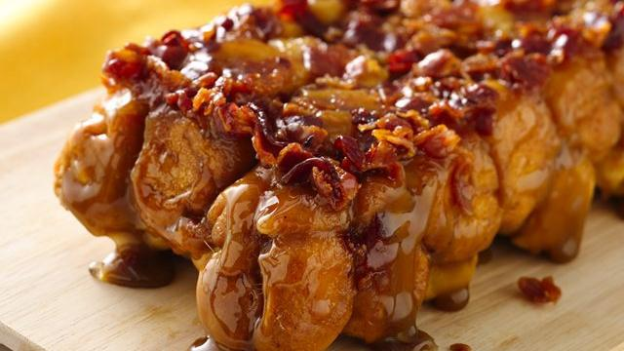
Maple Bacon Monkey Bread
Ingredients
1/4 Cup butter or margarine
3 tablespoons real maple syrup
1/4 cup packed brown sugar
1/4 teaspoon ground red pepper (cayenne)
6 slices bacon, crisply cooked, crumbled
2 cans (8 oz each) Pillsbury® refrigerated crescent dinner rolls
Heat oven to 350°F. Spray 8x4-inch loaf pan with cooking spray.
In medium microwavable bowl, microwave butter and syrup uncovered on High 30 to 45 seconds or until hot. Stir in brown sugar and red pepper until dissolved. Stir in bacon. Evenly spoon mixture into pan.
Unroll each can of dough into 1 large rectangle; press perforations to seal. Cut each rectangle into 8 rows by 3 rows, to make 24 pieces per rectangle (48 pieces of dough total). Roll each piece of dough into a ball. Arrange balls over butter mixture in pan.
Bake 30 to 35 minutes or until golden brown. Cool in pan 2-3 minutes. Place heatproof serving plate over pan; carefully turn plate and pan over. Remove pan. Serve warm.

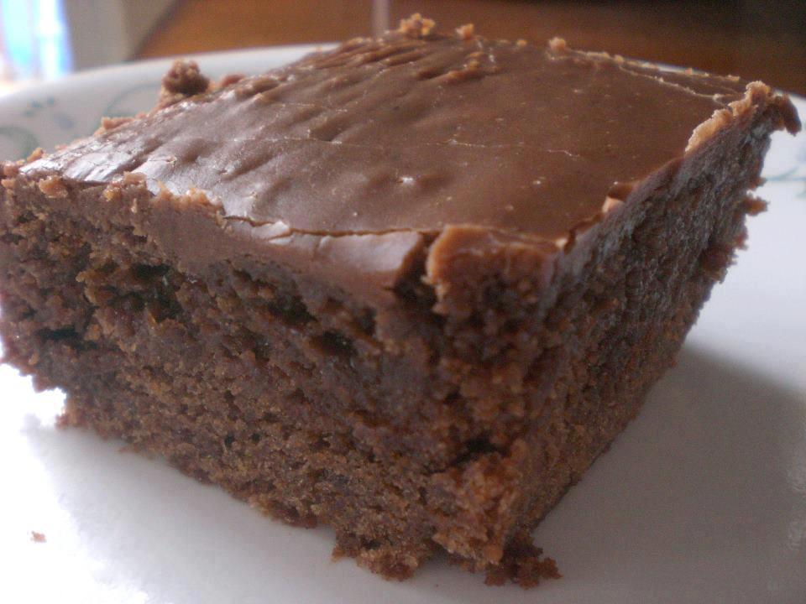
Double Chocolate Coca Cola Cake
1 cup Coca Cola (real thing, not diet)
1/2 cup oil
1 stick butter
3 Tablespoon cocoa
2 cups sugar
2 cups flour
1/2 teaspoon salt
2 eggs
1/2 cup buttermilk
1 teaspoon baking soda
1 teaspoon vanilla
Frosting:
1 stick butter
3 Tablespoon cocoa
6 Tablesppon of cream or milk
1 teaspoon vanilla extract
3 3/4 cups confectioner's sugar
In a saucepan, mix Coca Cola, oil, butter and cocoa and bring to a boil. In another bowl, combine the sugar, flour and salt. Pour the boiling Cola mixture over the flour mixture and beat well. Add the eggs, buttermilk, soda and vanilla and beat well. Pour mixture into a greased and floured 13 x 9 inch baking pan and bake at 350 degrees or 20 to 25 minutes. Remove pan. Cool for about 10 minutes before frosting.
Frosting: In a saucepan, combine the butter, cocoa, and milk. Heat until the butter melts. Beat in the remaining ingredients and spread on the cake while it's still warm.

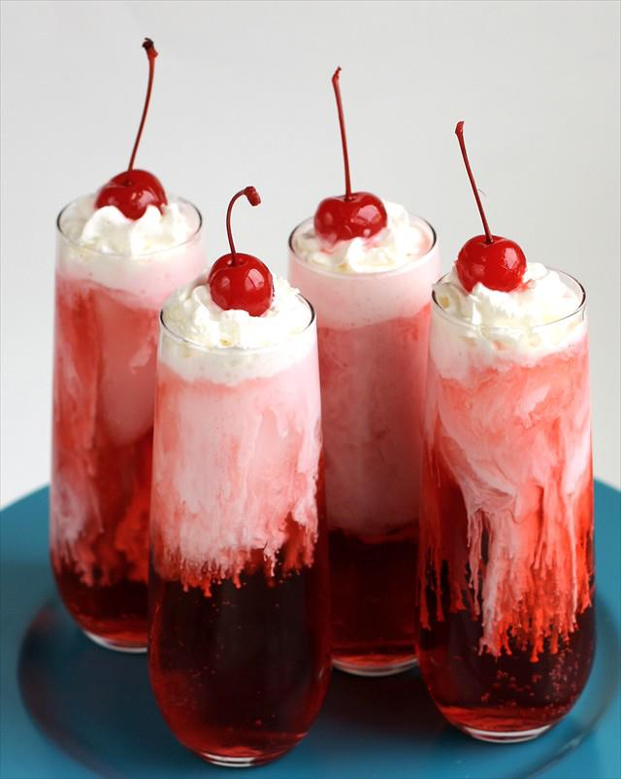
Italian Cream Sodas
What you'll need:
Club Soda
Half & Half
Flavoring Syrups
Ice
To make one Italian Cream Soda, you'll need:
1/2 cup Club Soda
3 TBSP Flavoring Syrup {our favorite combo was Raspberry Vanilla- 2 TBSP Raspberry to 1 TBSP Vanilla}
1 TBSP Half & Half
3 ice cubes
whipped cream and a cherry for the top!
Add ice cubes to glasses. Measure out about 1/2 cup Club Soda and pour into each glass. {If you have larger glasses, you can double all of the ingredients.}
Measure out 3 TBSP Flavoring syrup. You can find this type of syrup in the coffee section at just about any grocery store. I found vanilla everywhere but had a hard time finding any fruity flavors. I finally found Raspberry at Walmart. The bottles cost about $3.50 each and will make about 12-14 of the drinks at least.
Our favorite combo was a mix of vanilla and raspberry as detailed above. Yum.
Add the syrup to the soda. Just before serving add the 1 TBSP of Half & Half to the soda/ syrup mixture. This is the fun part- as the cream seeps down it makes a really cool design on the glass. Try and not shake the glasses around too much so that the design is preserved- serve with whipped cream and a cherry on top, as well as something to stir with prior to drinking. It's fun to admire the cool swirls of the syrup and cream, but encourage everyone to give it a little stir before drinking so that all the flavors meld.
ENJOY!
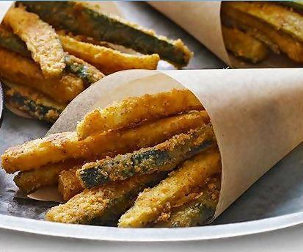
Oven-Baked Zucchini Fries
makes approximately 8 servings
Ingredients
3 zucchini (1 lb.)
1/4 cup Grated Parmesan Cheese
1 packet Shake & Bake Coating Mix
1 small egg
Method
Heat oven to 450ºF.
Trim the zucchini -cut crosswise in half, then cut each piece into 1/4-inch sticks. Add cheese to coating mix in shaker bag; shake gently to combine.
Whisk egg in medium bowl. Add zucchini; toss to coat. Use tongs to place 1/4 of the zucchini in shaker bag; close bag and shake to evenly coat. Spread onto baking sheet sprayed with cooking spray. Repeat with remaining zucchini.
Bake for 12 to 13 min. or until golden brown, turning the baking tray 180 degrees after 7 min to facilitate even baking.
Really Yummy if Dipped in Ranch Dressing.. or your favorite Dips.. I like the French Onion Dip or the Spinach Dip too.

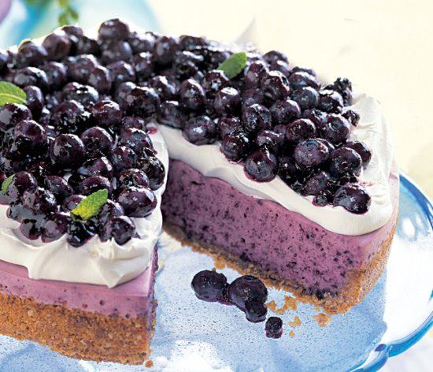
"No Bake Blueberry Cheesecake

Ingredients: Crust
9 whole graham crackers
1/2 cup old-fashioned oats
3 tablespoons (packed) golden brown sugar
1/8 teaspoon salt
5 tablespoons unsalted butter, melted
1 teaspoon vanilla extract
Filling:
1/4 cup water
1 tablespoon unflavored gelatin (measured from 2 envelopes)
12 ounces Philadelphia-brand cream cheese, room temperature
1 cup heavy whipping cream
1 cup sugar
1 tablespoon fresh lemon juice
3 cups fresh blueberries
Topping:
1 cup chilled heavy whipping cream
1 tablespoon sugar
4 1/2-pint baskets blueberries
2/3 cup blueberry jam
Preparation: Crust: Preheat oven to 350°F. Blend first 4 ingredients in processor until graham crackers are finely ground. Add butter and vanilla; process until moist crumbs form. Press crumb mixture onto bottom and 1 inch up sides of 9-inch-diameter springform pan. Bake crust until deep golden brown, about 12 minutes. Cool.
Filling: Pour 1/4 cup water into small saucepan; sprinkle gelatin over. Let stand 10 minutes. Stir over very low heat just until gelatin dissolves. Set aside.
Blend cream cheese, cream, sugar, and lemon juice in processor until smooth. Add berries; puree until smooth (some blueberry bits will remain). With machine running, add warm gelatin mixture through feed tube and blend well. Pour filling into crust. Cover; chill overnight. DO AHEAD Can be made 2 days ahead. Keep chilled. Run knife around pan sides to loosen cake. Release pan sides. Transfer to platter.
Topping: Beat cream and sugar in medium bowl until firm peaks form. Spread cream mixture thickly over top of cheesecake. Place berries in bowl. Heat jam in small saucepan over low heat until just melted. Pour jam over berries; toss to coat. Mound coated berries in center of cream, leaving 1-inch plain border. Chill cake at least 1 hour and up to 1 day.

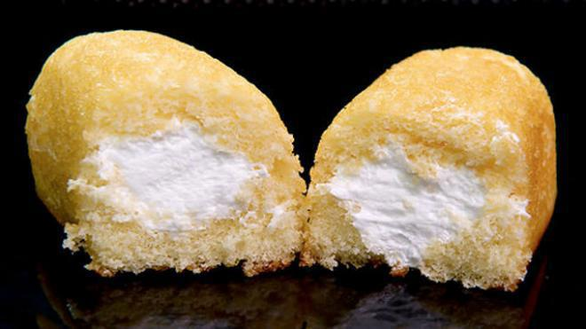
Homemade Twinkies
3 eggs
2 1/2 Cup sugar
1 1/2 Cup milk
1 1/2 Cup vegetable oil
1/2 Teaspoon baking powder
1/2 Teaspoon baking soda
1/2 Teaspoon salt
2 1/2 Cup flour
1/2 Teaspoon instant coffee
1 Teaspoon almond extract
Cream Filling
2 Cups cold heavy cream
1/2 Cup powdered sugar
1 vanilla bean or 1 teaspoon extract
Wisk the eggs, sugar, milk, oil and vanilla together. In a separate bowl combine all the dry ingredients. A little at a time add the dry to the wet until smooth.
Bake in the mold of your choice at 350 degrees until golden brown and is done in the middle when tested. When the cakes come out of the oven sprinkle a little sugar on the raw or sugar on top and for a little crunch.
Cream
Combine cream in a bowl and wisk until stiff. Inject into the cake using a baster.
Variations
For fun variations to take this Twinkie to the next level try adding lemon or orange zest to the cake batter before baking or almond extract and some chopped nuts.

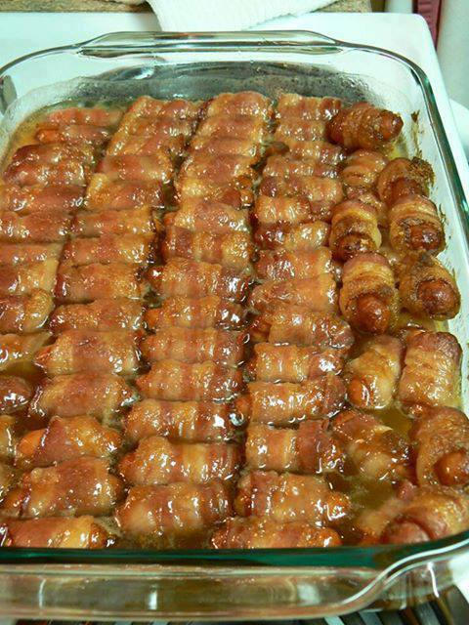
BACON WRAPPED SMOKIES
WITH BROWN SUGAR AND BUTTER
Warning: PARTY FOOD!I guarantee if you make these, they will be gone! I made them for a gathering and
everyone just kept eating them, and eating them …
Ingredients
1 pound Bacon, Cut Into Thirds
1 pound Lil’ Smokies (small sausages)
1 stick Butter
2 cups Brown Sugar
Preheat oven to 375F.
Cut the bacon into thirds and wrap each smokie.(small sausage)
Place all the wrapped smokies in a single layer in a baking dish.
Then melt the stick of butter and then 1 cup of brown sugar and stir until mixed well.
Pour the butter and brown sugar mixture on the smokies and bacon.
Then take the other cup of brown sugar and sprinkle evenly over the smokies.
Bake them for about 15-20 minutes and then turn the heat up to 400F for about 5 minutes or longer until the bacon becomes crispy.

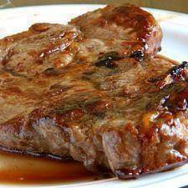
Crockpot Ranch Pork chops:
package of boneless pork chops
1 can of Cream of Chicken soup
1 packet dry Ranch dressing mix
In crockpot layer pork chops, add the cream of chicken soup, then sprinkle dry Ranch dressing all over.
Cover and cook on high for 4 hours OR Low for 6 hours.
The porkchops come out very tender and the flavor is amazing! You also get a good gravy for mashed potatoes

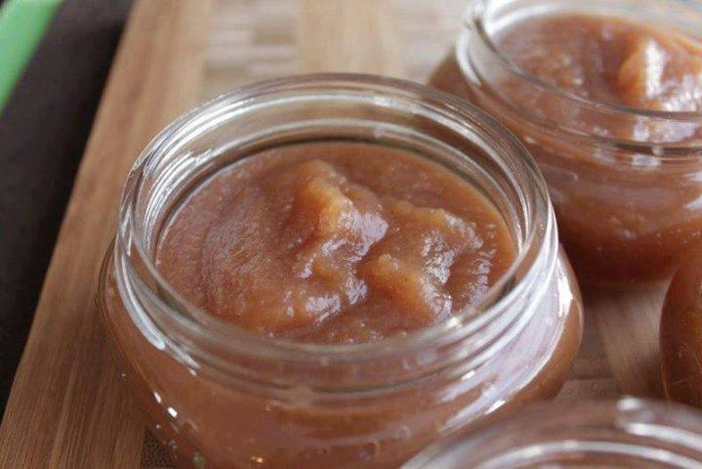
CROCK POT APPLE BUTTER
Approximately 3 lb. apples
3 cups sugar or your choice of sweetener
2 tsp. cinnamon
1 tsp. nutmeg
1/2 tsp. allspice
1/2 tsp. cloves
Dash of salt
3/4 cup water or fresh apple cider
Fill Crock-pot 3/4 full with peeled, cored and sliced apples. Add the remaining ingredients and stir until evenly mixed. Cover and cook on low setting overnight or until the butter is of a thick, spreadable consistency.
If apple butter has too much liquid, remove lid and cook on high until thickened. Stir often as butter thickens to prevent scorching.
Store in refrigerator for up to 6 weeks. Freeze for longer storage.
Variation: For a less sweet apple butter, substitute 1 cup honey for the sugar.
To can the apple butter, pack into hot jars leaving 1/4-inch headspace and process in a boiling water bath for 10 minutes.

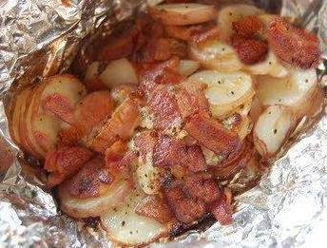
BACON ONION FOIL PACKS
2 to 3 sheets of heavy-duty foil
1 packet onion soup powder
10-12 baby red potatoes, thinly sliced
12 slices of cooked and crumbled bacon
1 cup cheese (optional)
Salt and pepper to taste
3 tablespoons butter
Sour cream for serving (optional)
Spray each sheet of foil with cooking spray. Top each piece with equal portions of potatoes, bacon, 1 packet onion soup powder and mix. Add salt and pepper to taste. Add 1 tablespoon of butter to each serving. Wrap securely.
Grill for 20 to 30 minutes. Or you can bake it in the oven, at 350° for about 35 minutes or till done. Let stand 10 minutes before serving. Serve in foil, topped with sour cream if desired.

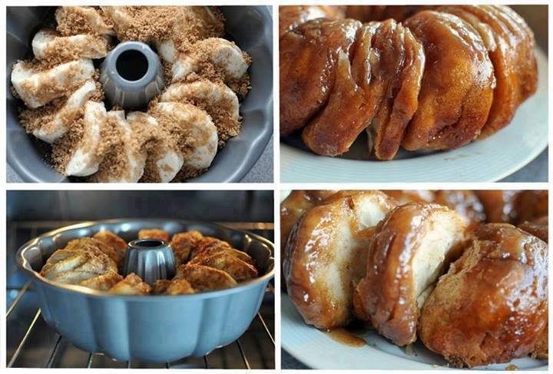
Sticky Bun Breakfast Ring
Ingredients:
2 small tubes refrigerator buttermilk biscuits OR 1 tube Pillsbury Grands buttermilk biscuits
3 Tbsp. butter, melted
1/2 C. pancake syrup (any brand you like, I used Mrs. Buttersworth)
1/3 C. packed light brown sugar
1/2 tsp. cinnamon
1/4 C. chopped pecans, optional
1/4 C. chopped almonds, optional
DO NOT SUBSTITUTE REAL maple syrup for the pancake syrup.
Instructions:
Spray a fluted pan with non-stick spray. Combine the melted butter and syrup in a small bowl and set aside. In another bowl, combine the brown sugar, cinnamon, and nuts (if desired). Place about half of the syrup mixture in the bottom of the pan. Then sprinkle half of the brown sugar mixture on top. Lay the biscuits on the bottom of the pan, overlapping edges (closely together) to form a ring. Top with remaining syrup and sugar mixtures. Bake at 375 degrees for approximately 20-25 minutes or until golden brown. Cool for 1 minute in the pan, then invert onto a serving platter and enjoy!
** I ended up using 1 1/2 tubes of the Pillsbury Grands buttermilk biscuits (1 tube didn't seem like enough) and baked it for about 30
minutes. It needed a bit longer to bake since I used more. @ tubes work great for cutting them apart.

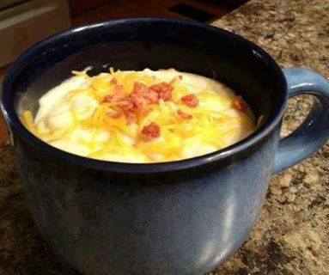
Crockpot Potato Soup for Weight Watchers
Tag or share to save it to your timeline!
Ingredients:
1 26-30 ounce bag frozen hash browns (plain)
2 14 ounce cans non-fat chicken broth
1 10-3/4 can 98% fat free cream of chicken soup
1/4 cup chopped onion
1/4 tsp pepper
1 - 8 ounce pkg lowfat (1/3 less fat) cream cheese
1 cup fat free milk
Directions:
Add first 5 ingredients to crockpot and cook on high for an hour
Stir and then turn to low for another hour.
Add cream cheese, and cook another 1/2 hour or until cheese can be stirred into mixture.
Add milk and cook 10 - 15 minutes longer.
Makes 8-10 cup servings
WW Pts+: 3.5 per cup
Optional: Garnish with chopped green onion and bacon bits. (Add 1 pt for garnish)
Variation: Use frozen Country potatoes or Potatoes O'Brien in place of the hash browns. Or for low carb use cauliflower!
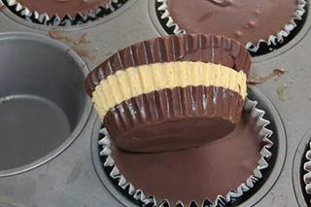
Peanut Butter Cups
If you’re looking for something quick and easy, you’ve gotta try this!
Ingredients:
16 oz semi-sweet or milk chocolate, chopped (or use chips)
2 Tablespoons unsalted butter, room temperature
1/3 cup confectioners sugar
1/2 cup creamy peanut butter
Directions:
In a small glass bowl, heat half of the chocolate in the microwave for 30-60 seconds. Remove from the microwave once the chips begin to slightly melt. Use a fork to stir until smooth, using the heat of the chocolate to melt the remaining chips entirely. If needed, re-heat in 10 second intervals until smooth. DO NOT over heat the chocolate, as it will burn and seize.
Line a muffin tin with cupcake papers. Spoon a small amount (about 2 teaspoons) of chocolate into the bottom of each paper. Tap the pan on your counter top to help smooth and spread the chocolate. Place the pan in the freezer for 15 minutes to harden the chocolate. Meanwhile, prepare the peanut butter.
In a small bowl, beat together peanut butter, butter and confectioners sugar until smooth and fluffy. Remove the pan from the freezer, and spoon a small amount of peanut butter on to the chocolate layer. Again, tap on counter top to level and spread the peanut butter. Return the pan to the freezer and allow to harden for about 15 minutes.
Repeat the first step and melt the remaining chocolate in the same manner. Spoon the top chocolate layer over the peanut butter and return to freezer.
Serve very cold, and enjoy!

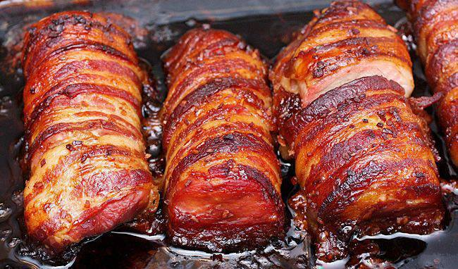
~~Jill’s Pork Tenderloin ~~~
3 pounds Pork Tenderloin (1 Pkg. Of 2 Tenderloins), Cut Into 4 Pieces Total
1 pound Bacon
¾ cups Soy Sauce
1 Tablespoon Minced Onions
½ teaspoons Garlic Salt
1 Tablespoon Wine Vinegar Or White Vinegar
¼ teaspoons Salt
1 dash Pepper
¾ cups Brown Sugar
Preparation Instructions
Wrap the tenderloin pieces in bacon. Place in an 8 1/2″ x 11″ pan. Poke holes in meat with a fork.
Combine rest of ingredients in a small bowl; stir well. Pour marinade over meat. Refrigerate, uncovered, 2 to 3 hours or overnight.
Bake in a 300 degree oven for two to three hours. If the bacon burns, place foil over the top after approximately 1 1/2 hours of baking. Remove from oven, cut meat into small pieces and allow the meat to soak up the excess juices in the pan.

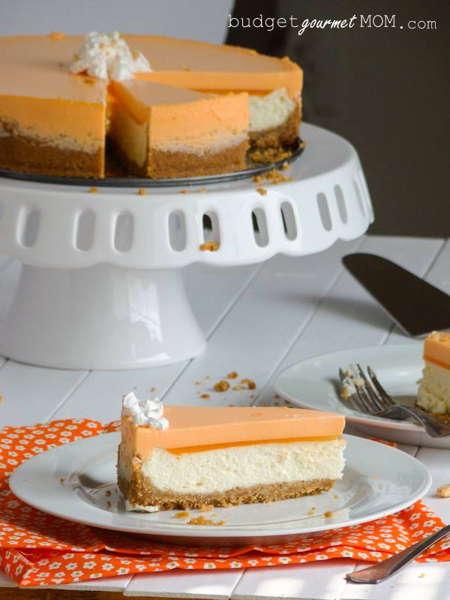
Orange Creamsicle Cheesecake
Ingredients:
Graham Cracker Crust
1/2 cup butter, melted
2 tablespoons granulated sugar
2 cups graham cracker crumbs
Cheesecake
2 - 8 oz packages cream cheese, softened
1/2 cup granulated sugar
1 teaspoon vanilla
2 large eggs
1/2 cup sour cream
Orange Creamsicle Layer
1 - 3 oz box orange flavored gelatin
1 1/2 cup boiling water
1 - 8 oz container of whipped topping such as Cool Whip
Instructions:
Preheat the oven to 325°. In a mixing bowl combine the butter, sugar, and graham cracker crumbs. Stir until combined. Pat into a 9" springform pan. Set aside. In a medium mixing bowl whip the cream cheese, sugar, and vanilla. Beat in eggs, one at a time then beat in sour cream. Pour the filling into the crust. Bake for 40 minutes. Turn of the oven and crack the oven door for 30 minutes. Remove from oven and allow to cool completely. Once cooled mix the creamsicle layer by stirring the gelatin with the boiling water until it dissolves. Then gently whisk in the whipped topping until it's completely combined. Pour over the cheesecake. Set on a plate or dish in case of dripping and place in the freezer for an hour. Remove from the freezer and chill in the refrigerator until ready to serve. I suggest chilling it over night. When ready to serve use a sharp knife and run it around the pan to separate the gelatin layer from the side. Unhinge the pan and gently lift from the cheesecake.
This cheesecake is best made the day before but can be made the day of as long as you plan accordingly and chill it for at least 2 hours.
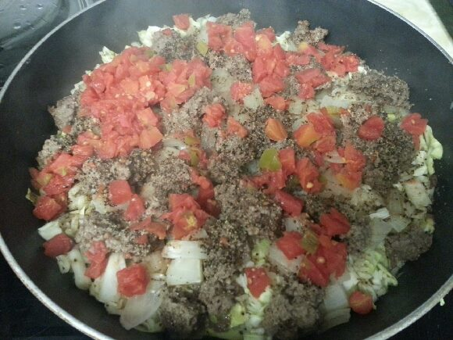
German Skillet Dinner~ absolutely wonderful
3 tbl butter or margarine
1/2 cabbage , chopped
2/3 c uncooked rice (I use minute rice)
1 med onion, chopped
2 lbs hamburger
1 can diced tomatoes or rotel tomatoes
Salt and pepper to taste
Melt butter in skillet, layer cabbage, uncooked rice, onion, raw crumbled hamburger, salt and pepper, then tomatoes. Cover with lid and simmer 25-35 minutes until rice, cabbage and burger are done. Do not stir or lift lid until done.

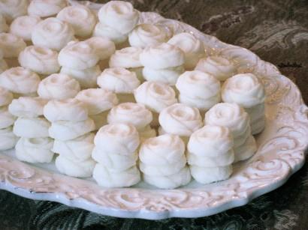
~ Cream Cheese Mints Recipe ~
sweet, minty, and melt-in-your-mouth creamy!
Ingredients:
8 ounces soft cream cheese
6 tablespoons soft butter
3/4 teaspoon pure peppermint extract (NOT mint extract)
2 pounds sifted powdered sugar
1/2 teaspoon vanilla extract
3 drops red food coloring
Combine and push mint mixture into a pastry bag, icing syringe or squeeze bottle with a decorative tip. Create desired shapes for mints. Let set 1 hour.

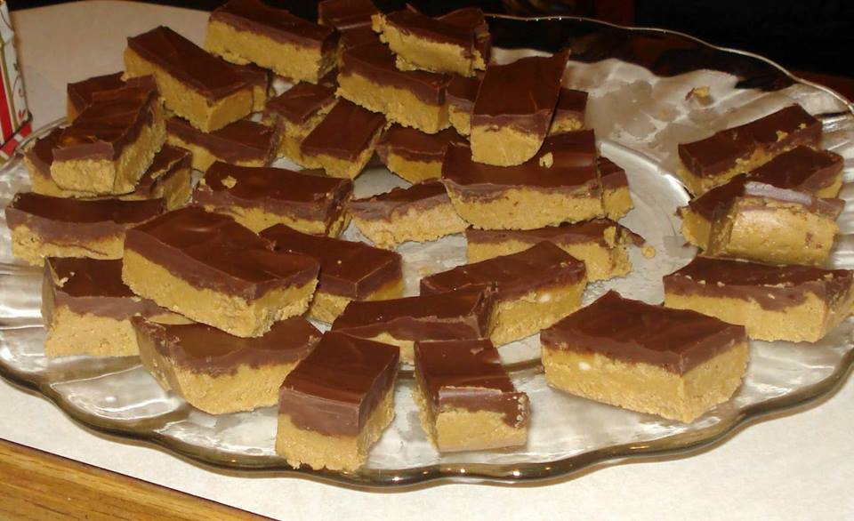
NO-BAKE PEANUT BUTTER BARS
1 cup salted butter (melted)
2 cups graham cracker crumbs
1/4 cup brown sugar
1 3/4 cup powdered sugar
1 cup peanut butter
1/2 tsp. vanilla
1 (11 ounce) bag milk chocolate chips
Combine all ingredients, except chocolate chips in a medium sized bowl. Stir until the mixture is smooth and creamy.
Pour peanut butter mixture into a 9x13 pan.
Melt chocolate chips in the microwave for 1-2 minutes. Stir chocolate and pour over the peanut butter mixture. Spread chocolate with a spatula.
Refrigerate bars for one hour. Cut while bars are still cool

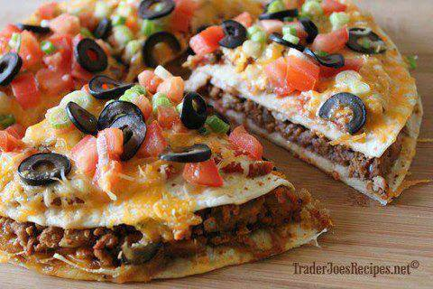
Mexican Pizza Recipe
Yield: 2 Mexican Pizzas
Prep time: 20 min | Cook time: 25 min
Ingredients
1/2 pound Trader Joe's Ground Beef or Ground Turkey
1 medium onion, diced
1 clove garlic, minced
1 tablespoon chili powder
1 teaspoon ground cumin
1/2 teaspoon paprika
1/2 teaspoon black pepper
1/2 teaspoon salt
1 15-oz can Trader Joe's Traditional Style Fat Free Refried Beans
4 9-inch flour tortillas
1/2 cup Trader Joe's Chunky Salsa, or your favorite salsa
2 cups Trader Joe's Lite 3 Cheese Blend
2 green onions, chopped
2 roma tomatoes, diced
1/4 cup Trader Joe's Extra Large Black Pitted Olives, sliced
Instructions
1.Preheat oven to 350°F.
2.Place meat, onion and garlic in a skillet over medium heat. Cook until beef is evenly browned. Drain off grease. Season the meat with chili powder, cumin, paprika, salt, and pepper.
3.Coat 2 pie plates with non-stick cooking spray. Place one tortilla in each pie plate and cover with a layer of refried beans. Spread half of the seasoned meat over each tortilla and then cover with a second tortilla. Bake for 10 minutes in the preheated oven. Remove from the oven and allow to cool slightly.
4.Spread half of the salsa over the top tortillas. Top each pizza with half of the cheese, tomatoes, green onions, and olives. Return the pizzas to the oven, bake until the cheese is melted, about 5 to 10 minutes. Remove from the oven and allow to cool slightly. Slice each pizza into 4 pieces and serve.
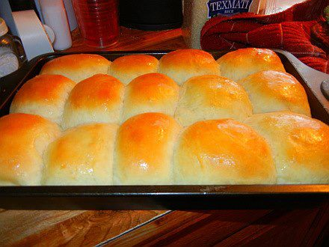
BEST EVER LIGHT AND FLUFFY DINNER ROLLS
4 cups all-purpose flour
1/3 cup sugar
1 teaspoon salt
1 package dry yeast
1 1/2 cups hot tap water
1 egg
1/3 cup softened butter
Sift together two cups of the flour with the sugar, and stir in the yeast. With mixer at low speed, blend butter into the flour mixture. Add the hot water (the hottest it comes from your tap, all at once, with mixer running. Add the egg, and continue mixing.
Add in the remaining two cups flour to make a soft dough.
(At this point, I changed my mixer beaters for dough hooks and let the mixer knead the dough for about ten minutes and then put it into an oiled bowl to rise.)
OR YOU CAN DO IT THIS WAY.
Knead lightly on a floured board and shape into a ball. Put into an oiled bowl, cover with a towel, and allow to rise in a warm spot until doubled, about two hours. Punch dough down. At this point it can either be refrigerated or shaped in rolls or loaves and allowed to rise a second time until doubled. Bake in a preheated 375 degree oven until barely brown. May be frozen after baking and reheated to serve.

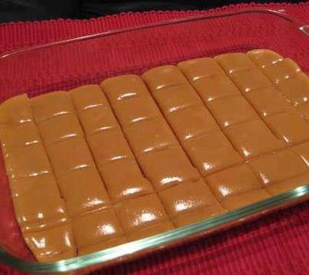
SIX MINUTE CARAMELS
I love caramels and this seems like the perfect, easy solution!
Ingredients
1/4 cup butter
1/2 cup white sugar
1/2 cup brown sugar
1/2 cup light Karo syrup
1/2 cup sweetened condensed milk
Directions:
1 Combine all ingredients.
2 Cook 6 minutes on a medium high heat, stirring every minute.
3 Stir and pour into lightly greased dish.
4 Let cool.
5 Cut, wrap in wax paper & store in an air tight container

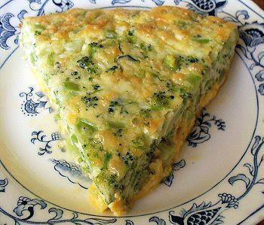
BROCCOLI QUICHE (low carb)
10 ounces frozen chopped broccoli, cooked and well drained
8 ounces cheddar cheese, shredded
2 ounces onion, chopped, about 1/3 cup
6 eggs
1 cup heavy cream
1 teaspoon salt
Dash pepper
Spray a large glass pie plate. Put the broccoli, onion and cheese in the bottom of the plate. Beat the eggs, then whisk in the cream, salt and pepper. Pour evenly over the cheese. Bake at 350º for 35-45 minutes, until a knife inserted in the center comes out clean. Let stand 10 minutes before cutting.
Makes 6 servings
Can be frozen
Per Serving: 379 Calories; 32g Fat; 18g Protein; 5g Carbohydrate; 2g Dietary Fiber; 3g Net Carbs

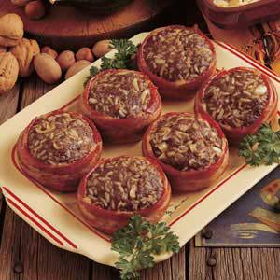
Mock Filet Mignon
1 1/2 lbs. lean ground beef
2 cups cooked rice
1 c. minced onion
1/2 teaspoon garlic powder
1 Tablespoon Worcestershire sauce
1 1/2 teaspoons salt
1/4 teaspoon pepper
6 slices of bacon
1. Combine all but bacon. Mix well with hands. Shape into 6 patties. Wrap a bacon strip around each. Place on a baking sheet and cover loosely with plastic wrap. Place in freezer just until patties are frozen. Place the patties in a gallon freezer bag, label and freeze.
2. To serve: Thaw. Secure bacon with a toothpick. Place on an ungreased shallow baking dish and bake 450 degrees for 20 minutes or to desired doneness.

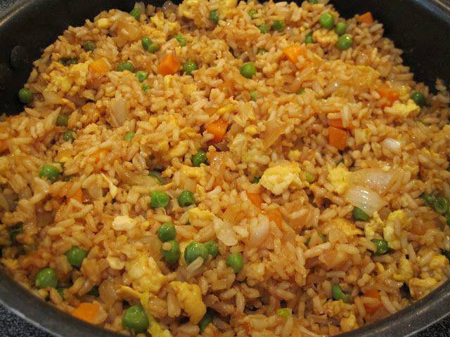
FRIED RICE
3 cups cooked white rice
3 tbs sesame oil
1 cup frozen peas and carrots (thawed)
1 small onion, chopped
1tsp minced garlic
2 eggs, slightly beaten
1/4 cup soy sauce
On medium high heat, heat the oil in a large skillet or wok. Add the peas carrots mix, onion and garlic. Stir fry until tender. Lower the heat to medium low and push the mixture off to one side, then pour your eggs on the other side of skillet and stir fry until scrambled. Now add the rice and soy sauce and blend all together well. Stir fry until thoroughly heated. Try adding some green onion.

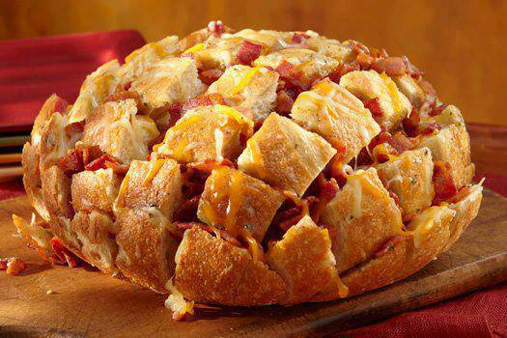
Bacon Cheddar Pull-Apart Bread
8 oz of your favorite shredded cheddar cheese blend.
1 large round loaf of soft bread (like a French or Italian round)
8 oz. diced sliced bacon, cooked crisp
1/2 cup melted butter
1 Tablespoon dry Ranch dressing mix from packet
Cut bread in 3/4-inch intervals, being careful to not cut all the way through. Cut again, crosswise, not cutting all the way through. Place cheese in between all cuts: sprinkle with bacon. Blend melted butter and Ranch mix and drizzle over top of bread evenly. Wrap in foil and bake at 350 degrees for 15 minutes; uncover and bake 10 minutes more. Serve hot and pull apart pieces from loaf to eat!

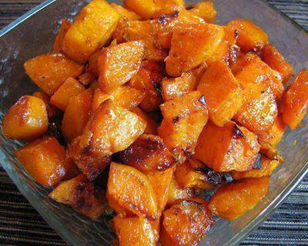
Roasted Sweet Potatoes
3 Sweet potatoes, peeled and cut into bite size cubes
2 tsp olive oil
1 tbsp butter
1 tbsp of brown sugar (organic)
1 tsp of ground cinnamon
1/4 tsp of ground nutmeg
Pinch of ground ginger
Sea salt, to taste
Directions:
Preheat the oven to 350 degrees.
Coat a small baking dish with cooking spray.
Peel and dice the sweet potatoes into bite size cubes and place in the baking dish.
Melt butter in the microwave and pour over the potatoes along with the olive oil, brown sugar, cinnamon, nutmeg, ginger and salt.
Add more sugar or cinnamon if desired.
Toss to coat evenly.
Bake in the oven for 60 minutes
Stir the sweet potatoes once or twice during roasting.

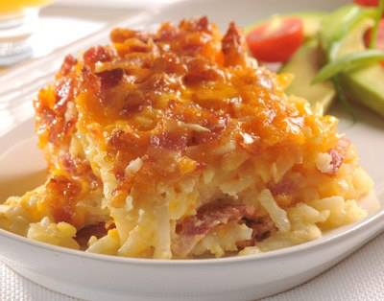
Bacon and Potato Bake
4 cups frozen shredded hash brown potatoes
1/2 cup onion (finely chopped)
8 ounces bacon, cooked and crumbled
1 cup (4 oz.) shredded cheddar cheese
1 12 oz. can Evaporated Milk
1 large egg, lightly beaten
1 1/2 teaspoons seasoned salt
Directions
Preheat oven to 350 degrees.
1).Spray an 8-inch-square baking dish with cooking spray.
2). Layer 1/2 potatoes, 1/2 onion, 1/2 bacon and 1/2 cheese in prepared baking dish. Repeat layering with remaining ingredients.
3). Combine evaporated milk, egg and seasoned salt in small bowl. Pour evenly over potato mixture and cover with aluminum foil.
4). Bake for 55 to 60 minutes. Uncover, then bake for an additional 5 minutes. Let stand for 10 to 15 minutes before serving.

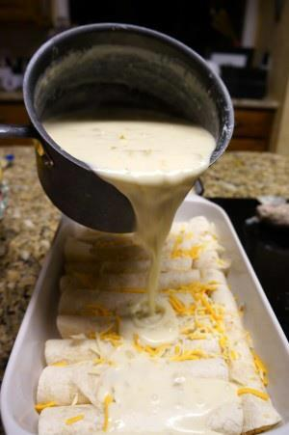
Chicken & Cheese Enchiladas
with Green Chili & Sour Cream Sauce
10 soft taco shells (smaller flour tortillas)
2 cups cooked, shredded chicken
2 cups shredded Monterey Jack cheese
3 Tbsp. butter
3 Tbsp. flour
2 cups chicken broth
1 cup sour cream
1 (4 oz) can diced green chillies
Preheat oven to 350 degrees. Grease a 9×13 pan. Mix chicken and 1 cup cheese. Roll up in tortillas and place in pan. In a sauce pan, melt butter, stir in flour and cook 1 minute. Add broth and whisk until smooth. Heat over medium heat until thick and bubbly. Stir in sour cream and chilies. Do not bring to boil, you don’t want curdled sour cream. Pour over enchiladas and top with remaining cheese, and if you like. diced green onions and black olives. Bake 22 min covered, remove foil and then high broil for 3 min to brown the cheese. Pico de Gallo is a nice garnish

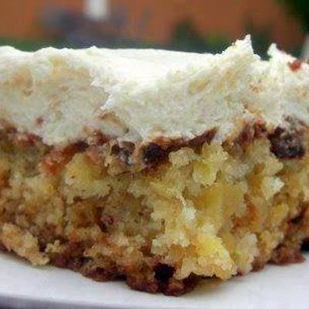
Pineapple Pecan Cake with Cream Cheese Frosting
Ingredients
2 cups flour
2 cups sugar
2 teaspoons baking soda
2 eggs
20 oz can crushed pineapple with juice
1 cup chopped pecans (optional)
Icing:
1 stick butter, softened
1 8oz cream cheese softened
2 cups confectioners’ sugar
1 tablespoon vanilla
Direction
Cake: Mix the dry ingredients. Add in the eggs, pineapple along with its juice, and the pecans. Stir just until moistened. Pour into a buttered 9x13 inch baking pan. Bake in a preheated 350 degree oven for about 35 minutes or until toothpick comes out clean. Cool completely. Make Icing: Combine cream cheese, butter, confectioners’ sugar, and vanilla. Beat until smooth. Frost cake using all the frosting. DELICIOUS!!!

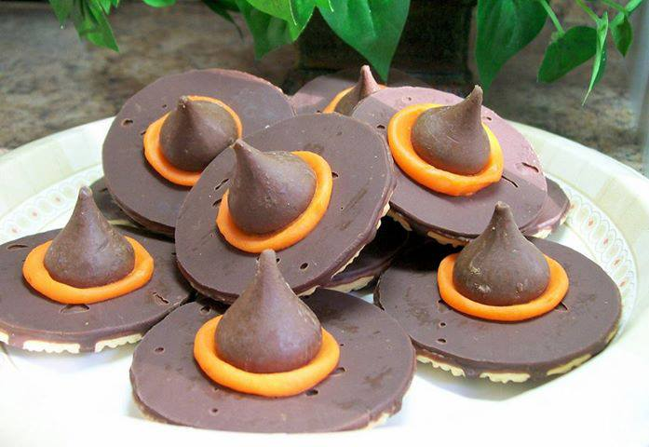
Hershey Kisses Witches Hats
What you need:
1 package (11.5 oz) fudge-striped shortbread cookies (32 cookies)
Hershey's® Kisses® brand milk chocolates, unwrapped
1 tube orange icing
Attach 1 chocolate candy to chocolate bottom of each cookie, using decorating icing.

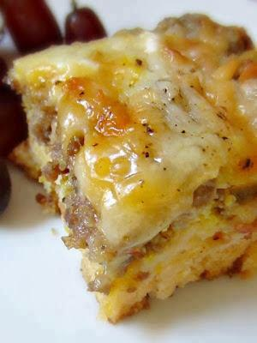
Sausage, Egg and Biscuits Casserole
1 can buttermilk biscuits any brand
1 lb Jimmy Dean sausage(or any brand of pork sausage)
1 c shredded mozzarella
1 c shredded cheddar
6 eggs
3/4 cup milk
salt & pepper to taste
Directions
Cut biscuits into six to eight pieces place in a grease 8x8 pan, brown sausage on the stove top and drain spread over the cut up biscuits, beat eggs and add milk and salt and pepper to them and pour over sausage and biscuits, sprinkle both shredded cheeses over the top.
Bake in 8x8 pan at 425 for 30-35 min. Let sit 5 min.

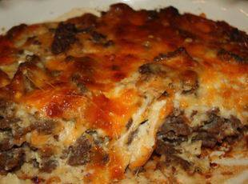
Cheeseburger Paradise Pie ~
Ingredients:
1 lb lean ground beef
1 large onion (chopped)
1/2 teaspoon of seasoned salt
1/2 teaspoon of garlic powder
a dash or worcester sauce
1 cup of shredded cheddar cheese (I used 3/4 cheddar and 1/4 mozzarella)
1 cup of milk
1/2 cup of Original Bisquick mix
2 eggs
Directions
1 Heat oven to 400°F.
2 Spray a 9 inch pie plate with non-stick cooking spray
3 Cook beef and chopped onion in a skillet over medium about 10 minutes or until beef is brown. Drain excess fat.
4 Stir in salt, garlic powder and worcester sauce and then spread in pie plate
5 Next, sprinkle the shredded cheese on top of the beef
6 In a small bowl, whisk together the milk, eggs and Bisquick. Make sure you try to get as many lumps out as you can. Pour over meat mixture.
7 Bake in oven for 25 minutes or until a knife comes out clean.

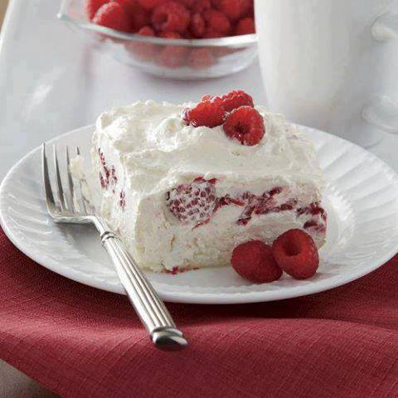
Raspberry Whip
What a delightful Summertime dessert!!
1 Angel food cake, broken into 1" bits
1 8 oz carton of Cool Whip (fat free or light)
1 C sour cream (or greek plain greek yogurt)
1 C powdered sugar (or stevia or homemade powdered sugar)*
1 pint red raspberries, well drained, fresh or frozen
In a medium bowl, mix together the Cool Whip, sour cream, and powdered sugar. Fold in raspberries. Place all the angel food cake bits in the bottom of a 9" x 13" baking dish. Pour the raspberry mixture over the cake. Cover the pan with plastic wrap and refrigerate one hour. Leftovers should be refrigerated immediately.

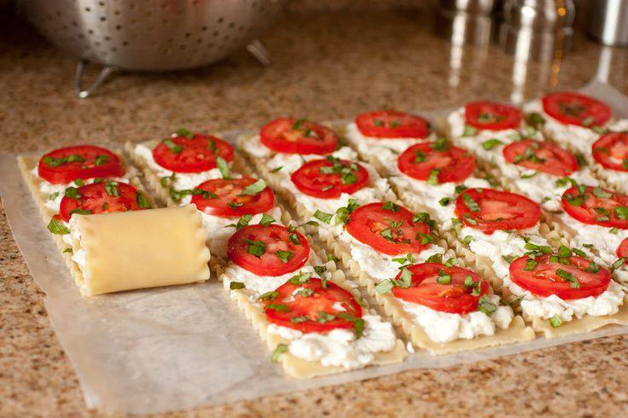
Caprese Lasagna Roll Ups –
loaded with Mozzarella, fresh tomatoes and fresh basil! Yummmmm!

8 lasagna noodles, uncooked
14 oz freshly shredded, low-moisture part skim Mozzarella cheese, divided
3/4 cup Ricotta cheese
1 large egg white
1/3 cup freshly, finely shredded Parmesan cheese (about 1 1/4 oz)
freshly ground black pepper
3 - 4 medium Roma tomatoes, thinly sliced (about 1/6 inch thick slices)
1/4 cup chopped fresh basil, plus more for garnish
1 cup marinara sauce, recipe follows
Simple Marinara Sauce
2 Tbsp extra virgin olive oil
1/4 cup finely chopped yellow onion
2 cloves garlic finely minced
1 (28 oz) can crushed tomatoes
salt and freshly ground black pepper to taste
Preheat oven to 350 degrees. Cook pasta according to directions listed on package to al dente. Drain pasta (DO NOT rinse with water) and align lasagna noodles in a single layer on a large sheet of parchment or wax paper. For filling, in a large mixing bowl, whisk together ricotta cheese and egg white until well blended. Stir in Parmesan cheese. Mix in 12 oz. of the Mozzarella cheese and season with black pepper to taste (I wouldn't recommend seasoning with salt just because the cheeses already have plenty of salt). Place 1/4 cup of the cheese mixture over each lasagna noodle and spread into an even layer, going from one end of the lasagna to the other. Align 4 thin tomato slices over cheese mixture then sprinkle fresh basil over top. Snugly roll lasagna noodles to opposite end. Spread about 1/4 cup pasta sauce in the bottom of an 11 x 7 inch baking dish. Align lasagna roll ups, seam side down in dish. Top each roll up with about 2 Tbsp of the pasta sauce (covering edges of pasta so they don't dry out while baking). Sprinkle top with remaining 2 oz. shredded Mozzarella. Bake in preheated oven 30 minutes. Remove from oven, plate pasta and garnish with plenty of basil ribbons. Serve warm.
Simple Marinara Sauce
Heat olive oil in a medium saucepan over medium high heat. Add onions to hot oil and saute about 3 minutes until soft, adding garlic during last minute of sautéing. Pour in crushed tomatoes and season with salt and pepper to taste. Bring mixture just to a boil, then reduce heat to a simmer and allow sauce to cook for about 25 - 30 minutes (which will allow some of the water in crushed tomatoes to evaporate) while you prepare pasta and lasagna filling (you can freeze or refrigerate left over sauce in a small airtight container for later use, adding fresh basil if desired).
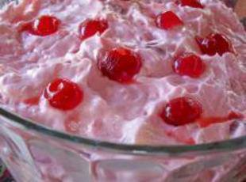
Cotton Candy Salad!!
Ingredients:
...
-1 can eagle brand milk
-2 cups crushed pineapple, drained well
-1 can strawberry pie filling
-1 can cherry pie filling
-12 oz. tub cool whip
-3/4 cup pecans, chopped
-Fold all ingredients together. Chill and serve.

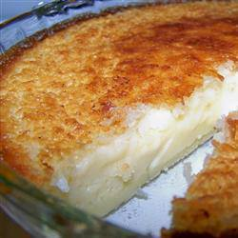
Impossible Pie
All the ingredients are mixed together and poured into a pie tin, but when it cooks it forms its own crust with filling This has a coconut vanilla taste like a coconut cream pie
Ingredients
2 cups milk
1 cup shredded coconut
4 eggs
1 teaspoon vanilla extract
1/2 cup all purpose flour
8 Tablespoon butter
3/4 cup sugar
1/4 teaspoon ground nutmeg
Directions
Place milk, coconut, eggs, vanilla, flour, butter and sugar in blender. Mix well.
Pour into a greased and floured pie plate. Sprinkle nutmeg on top.
Bake at 350 degrees for 45 minutes.

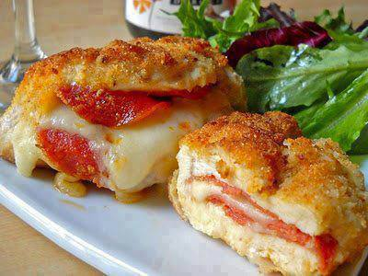
Pepperoni & Mozzarella Stuffed Chicken Breasts
INGREDIENT
1 lb. boneless, skinless chicken breasts
2 oz. mozzarella cheese
1.25 oz. (approx. 16 slices) pepperoni
1 large egg
1/2 cup bread crumbs (low carb use crushed pork rinds)
6 Tbs vegetable oil
to taste salt and pepper
STEP 1: Trim the chicken breasts. Slice each breast in half diagonally to create two diamond-like shaped pieces. Using a small, sharp knife, cut a pocket into the side of each breast piece. This can be slightly tricky on thinner pieces so be careful. Be sure not to cut all the way through the meat but rather just into one side so that the fillings will stay in.
STEP 2: Stuff each piece of chicken with 1/2 oz. of cheese and about 4 slices of pepperoni. Lightly season each piece with salt and pepper. Set the stuffed chicken aside.
STEP 3: Preheat your oven to 350 degrees and line a baking sheet with aluminum foil. Begin to heat a large skillet with 6 Tbsp of vegetable oil over medium/high heat. Collect three shallow dishes and put the flour in one, the egg in another and the bread crumbs in the third (Pampered Chef Coating Trays would be great for this). Beat the egg until it is an even consistency (adding a 1/2 tsp of water helps break it up).
STEP 4: One by one, coat each piece of chicken in the crushed pork rinds , then the egg .. Use your hands so that you can keep the open side of the pocket pinched closed and keep the fillings in.
STEP 5: Test the oil in the skillet to see if it is hot enough by dropping a small pinch of pork rinds in. The pork rinds should sizzle and dance A LOT. It is very important that the oil is hot enough or else the breading will soak up a lot of oil and you’ll end up with some really greasy chicken!. Place all four pieces of chicken in the skillet and cook until it is golden brown and crispy on each side. This should take no more than 2-3 minutes.
STEP 6: When you remove the chicken pieces from the skillet, transfer them to the baking sheet and place it in the oven. Finish baking the chicken (to cook the inside) for about 25 minutes (longer if you have larger pieces). Remove from the oven (check to make sure the chicken is cooked through) and serve immediately!

